Contents

01 IDENTIFY CHALLENGE 3

02 ASSET IDENTIFICATION 14

03 FIREWALL SETUP 19

3.1 Firewall Planning 20

3.1.1 Mapping the Network 20

3.1.2 Network Mapping: Web Server 20

3.1.3 Network Mapping: Mail Server 21

3.1.4 Network Mapping: MySQL Server 21

3.1.5 LAN Machines 22

3.1.6 Login to Kali 22

3.1.7 Login to PfSense 22

3.1.8 Interfaces 22

3.2 LAN and Web Server Rules 23

3.2.1 Firewall Rules 23

3.2.2 Stateful Rules 23

3.2.3 Safety First 23

3.2.4 Blocking all WAN traffic 24

3.2.5 Blocking DMZ traffic 25

3.2.6 Configure the LAN 26

3.2.7 Allow outbound HTTP 27

3.2.8 Allow outbound HTTPS 28

3.2.9 Allow Mail Server Traffic 29

3.2.10 DMZ Rules 31

3.3 WAN and MySQL Rules 33

3.3.1 Configure WAN 33

3.3.2 Block reserved networks 33

3.3.3 Firewall Rules List 34

3.3.4 HTTP WAN Rules 34

3.3.5 HTTPS WAN Rules 36

3.3.6 Mail Server WAN Rules 37

3.3.7 Web Server WAN Rules 38

3.3.8 Testing MySQL 39

3.3.9 MySQL LAN Rules 39

3.3.10 MySQL LAN Rules II 39

3.3.11 MySQL DMZ Rules 40

3.3.12 Testing MySQL 41

3.3.13 Successful Connection 41

Appendix Kali Tools 43

Appendix IPv4 Subnet Calculator 46

Appendix Check Local & External IP address on Kali Linux 48

Objective 48

External IP Address 48

Using WEB Browser 48

Using Command Line 48

Internal IP Address 48

Checking GUI Network Settings 48

Using ip or ifconfig commands 49

Appendix Demystifying ifconfig and Network Interfaces in Linux 49

ifconfig 49

Network Interface 49

Demystifying ifconfig output 50

Interfaces 50

Interface details 50

Interface stats 51

Summary 51

Appendix The "arp" Command 51

# 01 IDENTIFY CHALLENGE

|  |  |
| --- | --- |
| TASK | KEY PERFORMANCE INDICATORS |
| Recorded Kali's IP address | **K0471**: Knowledge of Internet network addressing (IP addresses, classless inter-domain routing, TCP/UDP port numbering) |
| Recorded Kali's MAC address | **K0491:** Knowledge of networking and Internet communications fundamentals (i.e. devices, device configuration, hardware, software, applications, ports/protocols, addressing, network architecture and infrastructure, routing, operating systems, etc.) |
| Scanned LAN with Nmap | **K0618:** Knowledge of hardware asset management and the value of tracking the location and configuration of networked devices and software across departments, locations, facilities and, potentially, supporting business functions. |
| Scanned DMZ with Nmap | **K0618:** Knowledge of hardware asset management and the value of tracking the location and configuration of networked devices and software across departments, locations, facilities and, potentially, supporting business functions. |
| Found true MAC address of network threat | **S0229:** Skill in identifying cyber threats which may jeopardize organization and/or partner interests.  **T0019:** Assess threats to and vulnerabilities of computer system(s) to develop a security risk profile.  **T0023:** Characterize and analyze network traffic to identify anomalous activity and potential threats to network resources. |

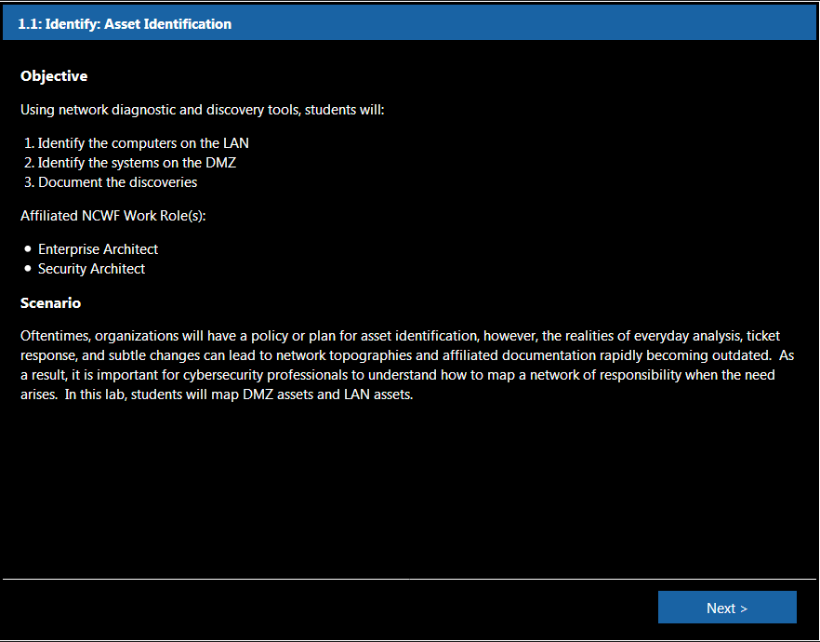

Before we begin our asset identification, type **ifconfig** to take a look at our network interface card (NIC).  
It looks like our **eth0 interface's IP address** is 10.0.1.2 with a **netmask** of 255.255.255.0

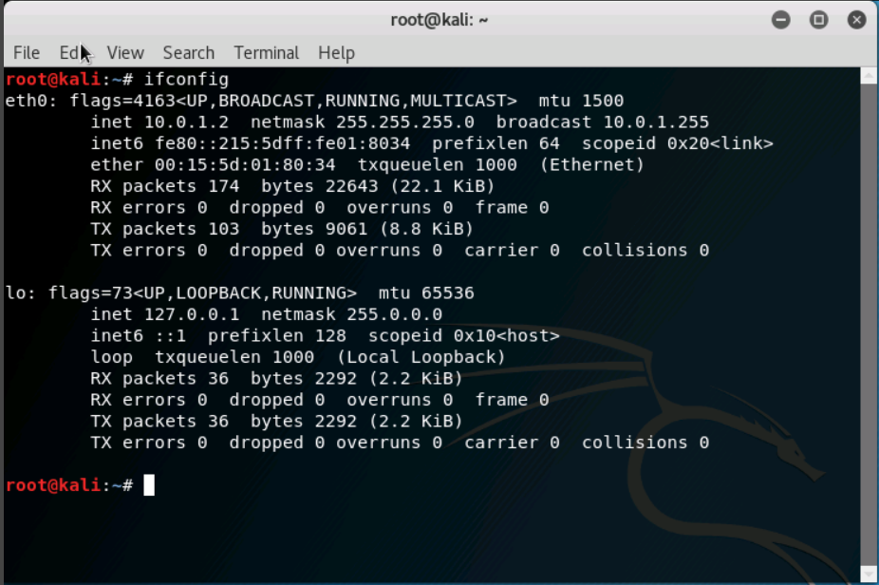

Now, let's figure out our gateway.  
Type **route -n** to see routing information. It looks like our gateway is 10.0.1.1 with a netmask of 255.255.255.0.

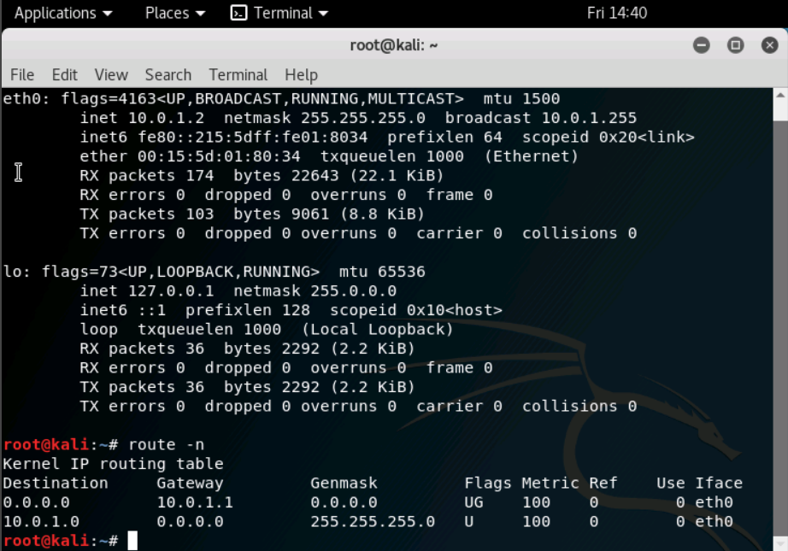

Before we identify our assets on the LAN, let's send ICMP echo requests to the internal router to see if it is up.  
Type **ping 10.0.1.1.** We can see that the router is communicating back to this Kali machine.  Type **CTRL C** to stop the requests.

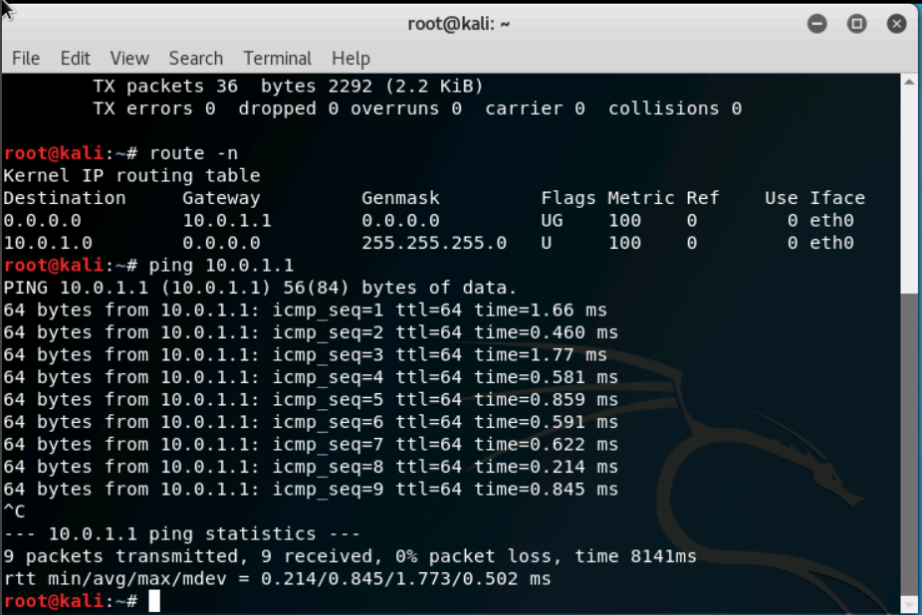

Type **netdiscover -r 10.0.1.1/24** to run the tool.  
Netdiscover has located not only the router, but also two other machines on the LAN as well.  Type **CTRL C** to go back to the original prompt.

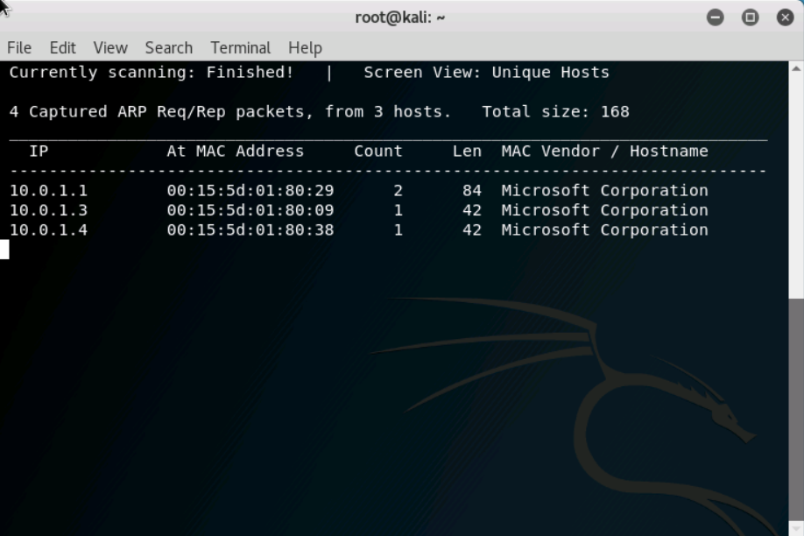

In the next few steps, we will be using nmap, which is short for network mapper.  Nmap is not only very powerful, but it is also very popular within the cybersecurity community.  
Type **man nmap** to learn more about the Command Line Interface (CLI) tool.  Type **q** when you are finished learning about nmap and its associated options.

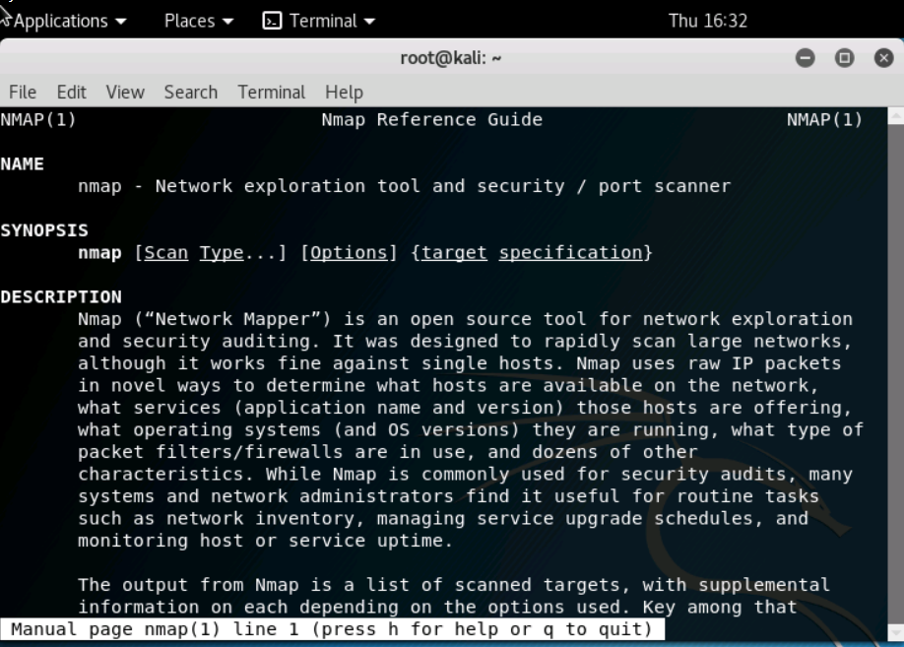

Let's conduct a ping scan, also known as a ping sweep, on the LAN.  Type **nmap -sn 10.0.1.1/24**.  The /24 is referring to the netmask of 255.255.255.0 that the subnet has. This nmap scan confirms our findings from the **netdiscover scan** to be true.  Both scans show that the router, as well as two other IP addresses, are up and running.  The third host's address is the eth0 IP of our Kali machine.

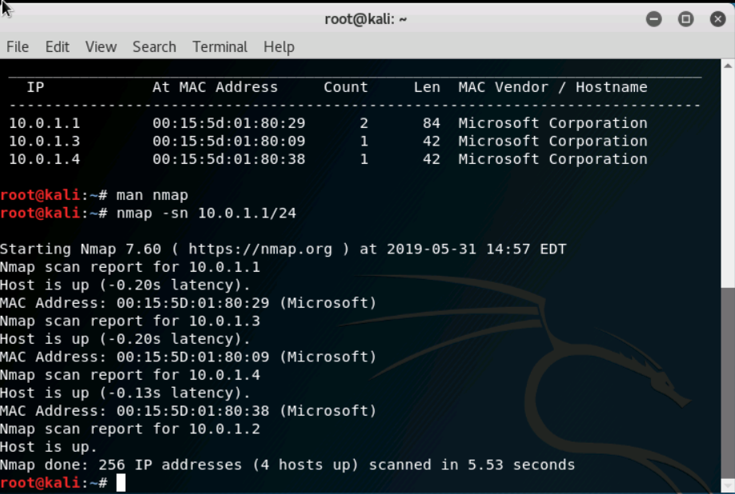

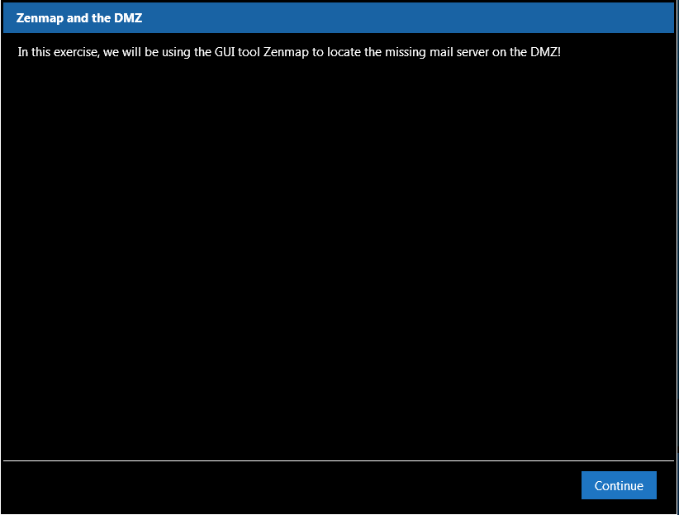

Let's move on from the LAN to the DMZ. Type **ping 10.100.1.2** to send ICMP echo requests to the same router, but to the DMZ-facing interface. We can see that the router is communicating back to this Kali machine. Type **CTRL C** to stop the requests.

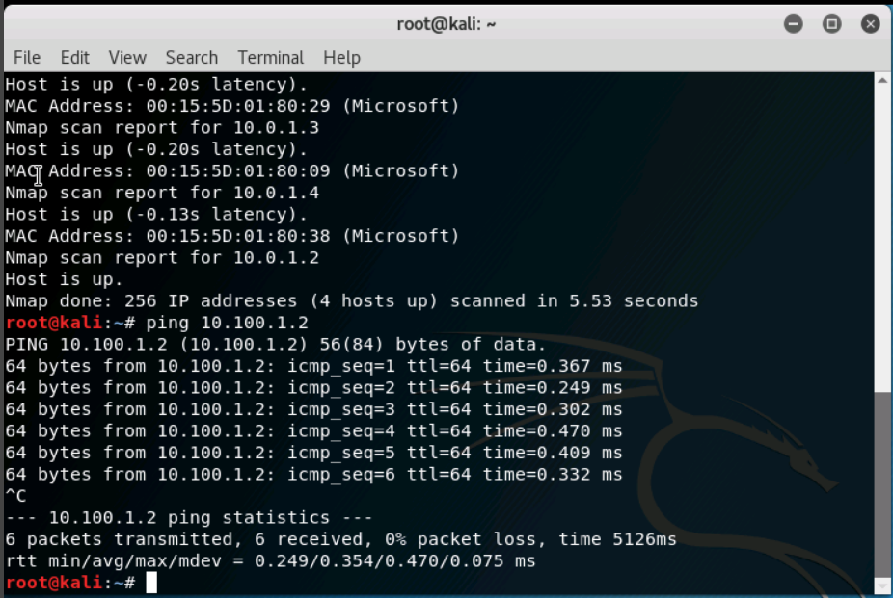

Before we identify our assets on the DMZ, let's see what the network is supposed to look like. Underneath the "Machines" tab on the right side, click on "Network Diagram".  Resize the window to see the whole picture if need be. Click "OK" to go back to your terminal session.

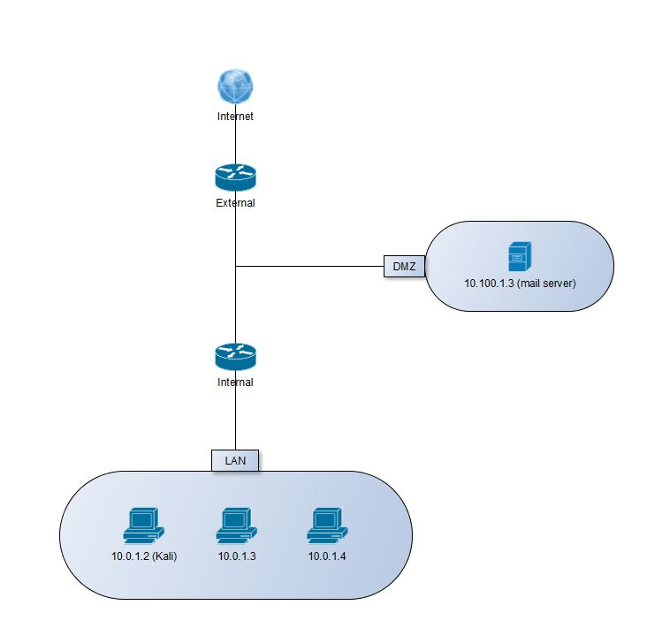

This is what our network should look like.  Note:

* Our LAN's nmap scan is accurate because it matches the LAN in this diagram
* Additionally, a mail server is in the DMZ with an IP address of 10.100.1.3

In the next couple of steps, we will be using the Graphical User Interface (GUI) version of nmap called Zenmap to locate the mail server! In the terminal, type **zenmap &** to run the process. In the target box, type **10.100.1.1/24** to use the DMZ IP range. In the profile drop-down box, select "Quick Scan". Click "Scan". Eureka!  The scan output shows two IP addresses! **10.100.1.2** is the internal router's DMZ-pointing interface.  However, take a look at **10.100.1.39**.  It has open ports hosting various services! Services like **SMTP, POP3, IMAP, SUBMISSION, IMAPS**, and **POP3S** are protocols specifically designed for sending and receiving emails to and from the Internet. For this scenario, it is safe to assume that we have found the misplaced mail server. Save the scan by selecting "Scan" > "Save Scan". Save the Zenmap scan as dmz.xml on the Desktop. Close your Zenmap window.

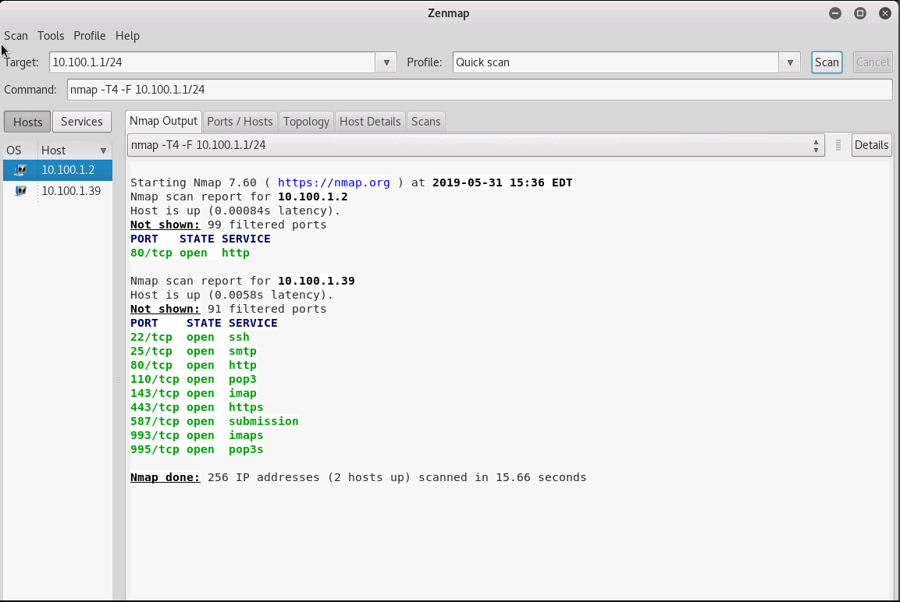

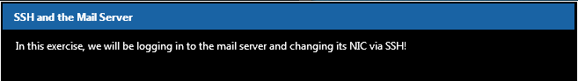

Once we have the XML file saved, let's use SSH to remotely log into the mail server and change its IP address. In your terminal, type **ssh** [root@10.100.1.39](mailto:root@10.100.1.39)**.**

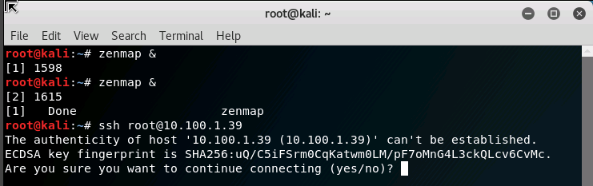

Type **yes** to establish the authenticity.  From our admin records, we know that the mail server password is **packethunters**.

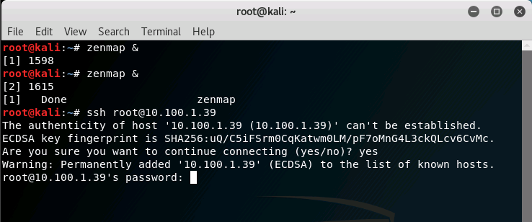

In order to correctly change the IP address, we need to execute two different commands.  We will use "&&" to combine the ifconfig and route commands. Type **ifconfig eth0 10.100.1.3 netmask 255.255.255.0 && route add default gw 10.100.1.2.** After you hit **ENTER**, close out of the terminal window.

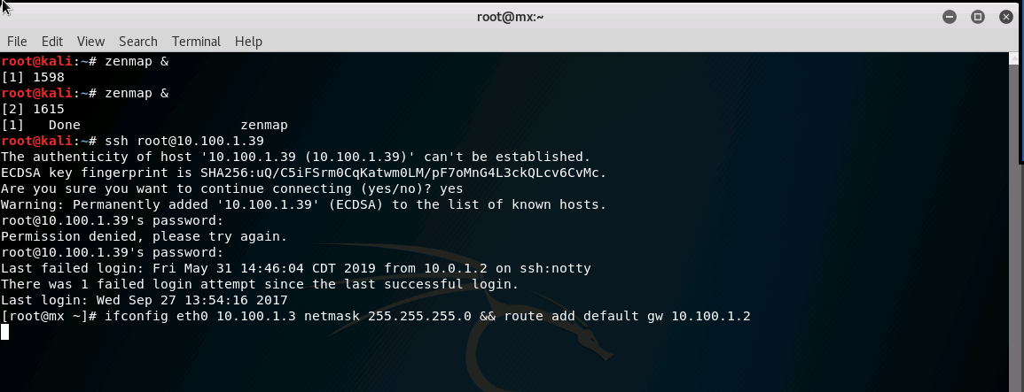

Let's make sure our mail exchange has the correct IP address that we just assigned to it. Open up a Firefox web browser and navigate to <https://10.100.1.3>**.** Click "Advanced", "Add Exception...", and "Confirm Security Exception" to pass the certificate security warning.

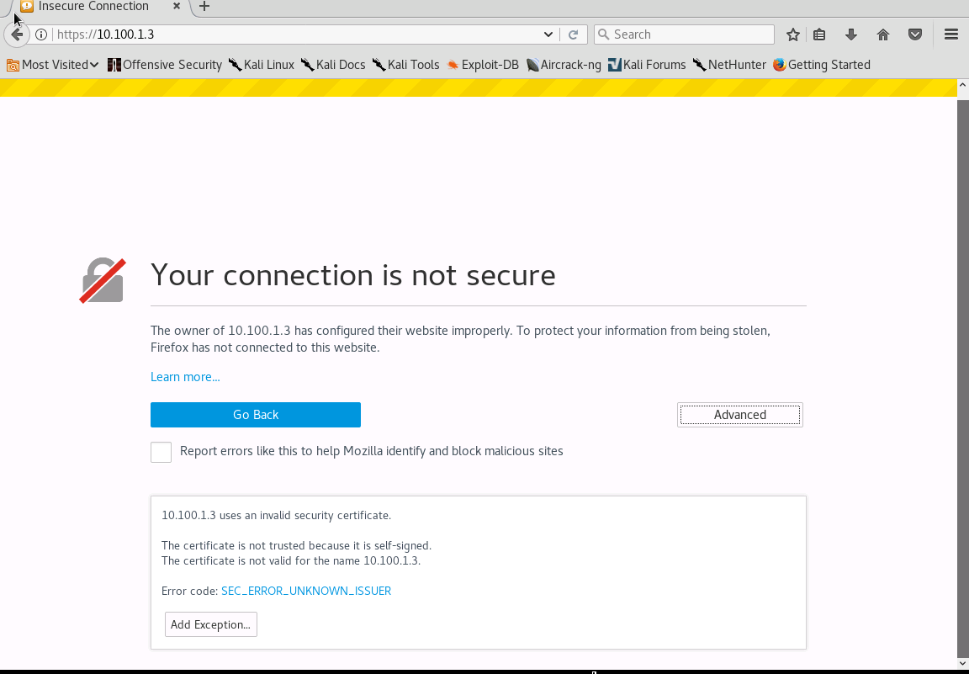

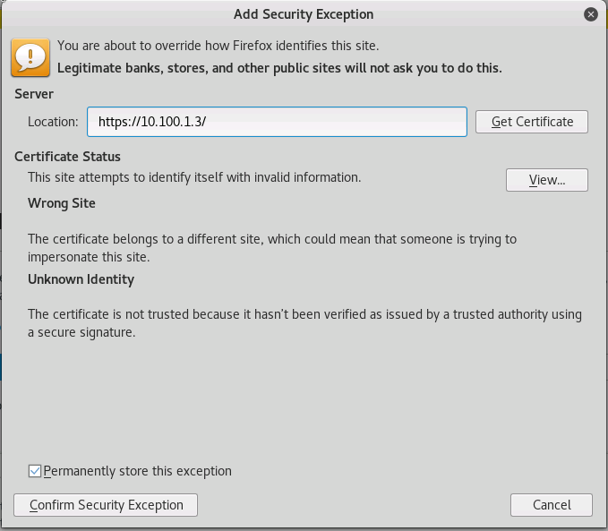

When you get to the webmail login page, close out of Firefox.  We have successfully placed the web server in its correct location within the DMZ!

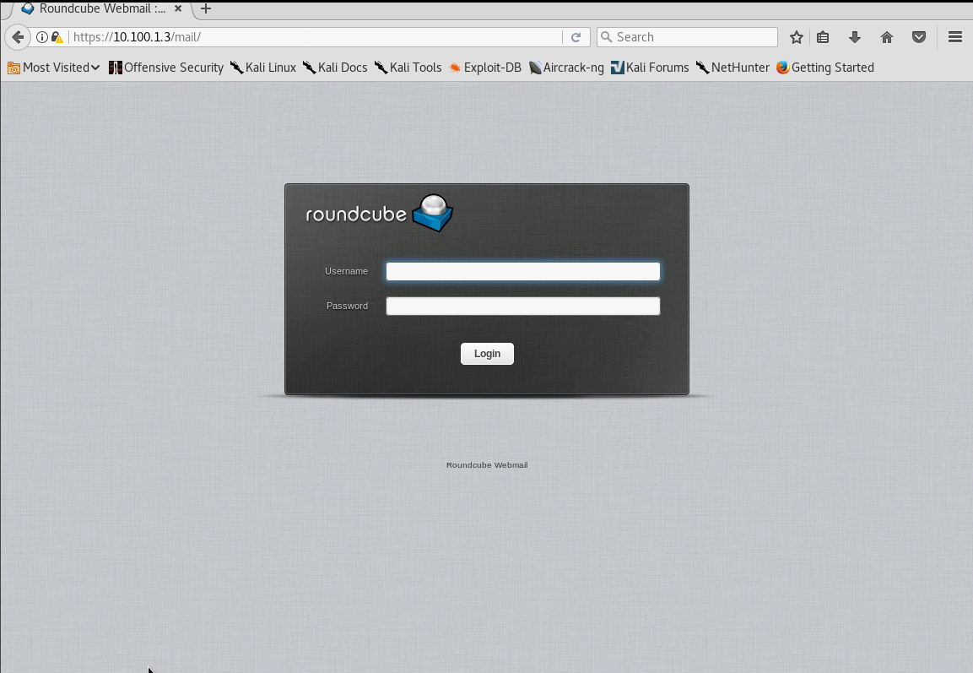

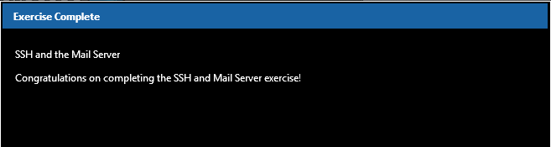

Exit out of your terminal and close all of your windows. On the Kali Desktop, submit your Nexus credentials to Evalu8R in order for your work to be graded.

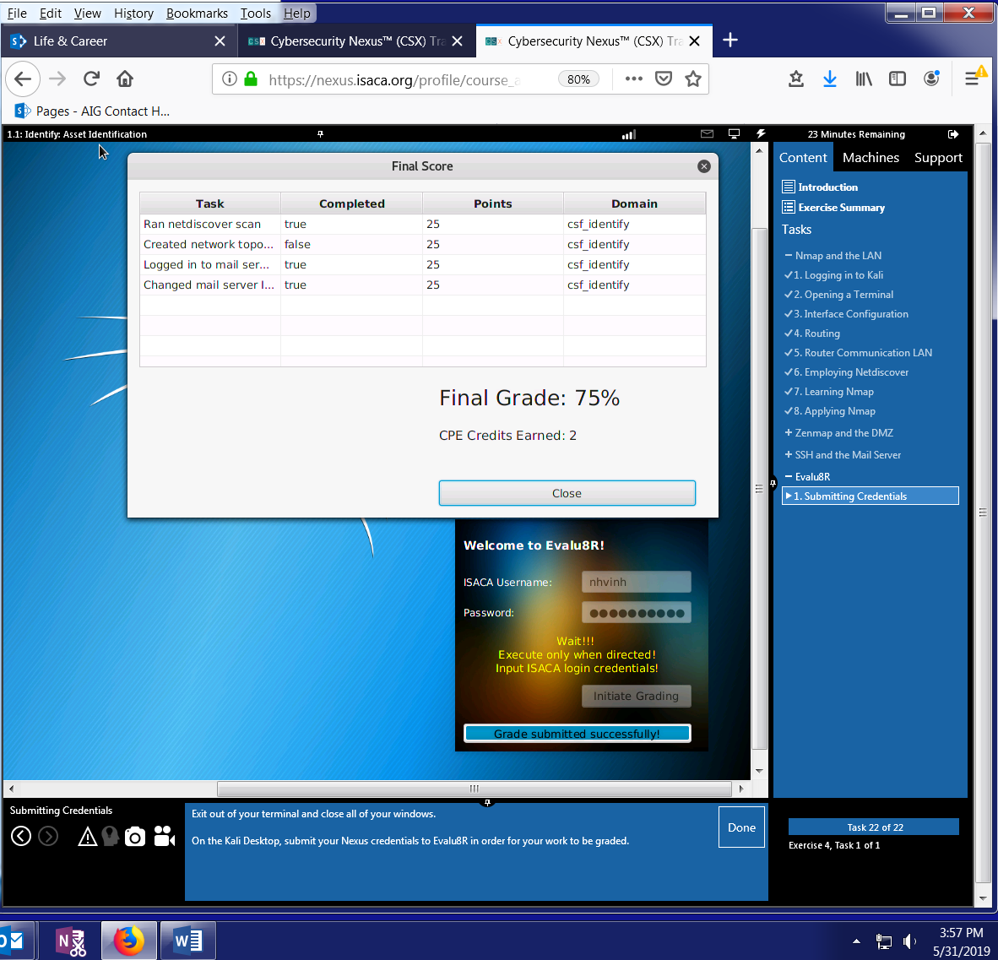

# 02 ASSET IDENTIFICATION

|  |  |
| --- | --- |
| TASK | KEY PERFORMANCE INDICATORS |
| Ran netdiscover scan | **S0081**: Skill in using network analysis tools to identify vulnerabilities. (e.g., fuzzing, nmap, etc.) |
| Created network topology with Zenmap | **S0081:** Skill in using network analysis tools to identify vulnerabilities. (e.g., fuzzing, nmap, etc.).  **K0179:** Knowledge of network security architecture concepts including topology, protocols, components, and principles (e.g., application of defense-in-depth).  **K0255:** Knowledge of network architecture concepts including topology, protocols, and components.  **K0487:** Knowledge of network security (e.g., encryption, firewalls, authentication, honey pots, perimeter protection) |
| Logged in to mail server via SSH | **T0553: Apply cybersecurity functions (e.g., encryption, access control, and identity management) to reduce exploitation opportunities.**  **K0049: Knowledge of information technology (IT) security principles and methods (e.g., firewalls, demilitarized zones, encryption)** |
| Changed mail server IP address | **K0470: Knowledge of Internet and routing protocols.**  **K0471: Knowledge of Internet network addressing (IP addresses, classless inter-domain routing, TCP/UDP port numbering)** |
|  |  |

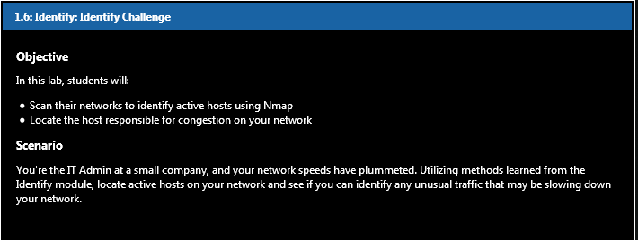

Create a file named IncidentReport.txt on your Desktop. We'll be using this file to document current network information. In the file, record your IP address, MAC address, and any other information that may benefit your investigation.

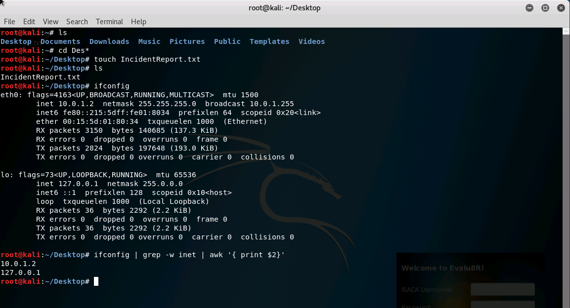

**eth0** (physical interface) and **lo** (special virtual network interface – loopback device for diagnostics and troubleshooting and for connecting to services on local host). A media access control address (MAC address) of a device is a unique identifier assigned to a network interface controller (NIC) for communications at the data link layer of a network segment. MAC addresses are used as a network address for most IEEE 802 network technologies, including Ethernet and Wi-Fi.

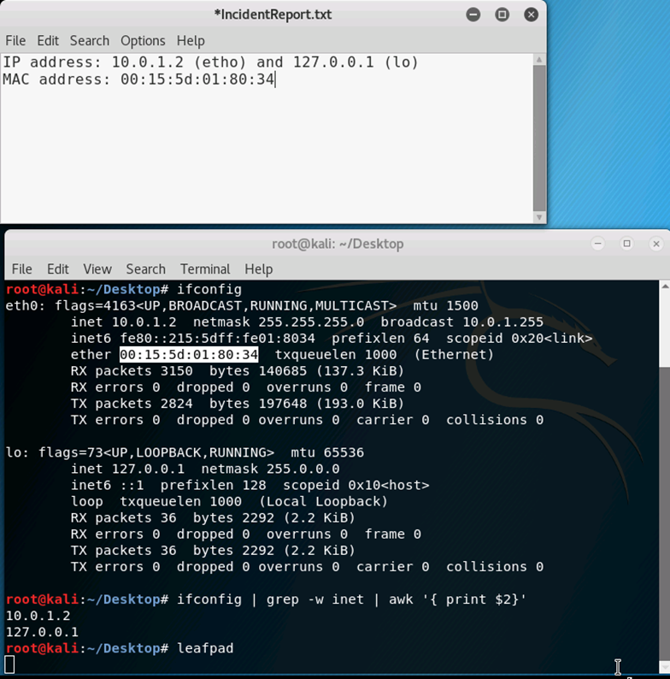

**Scan** the LAN (10.0.1.0/24) and DMZ (10.100.1.0/24) network segments with nmap. In your IncidentReport.txt file, **record** which IP's were discovered on each segment.

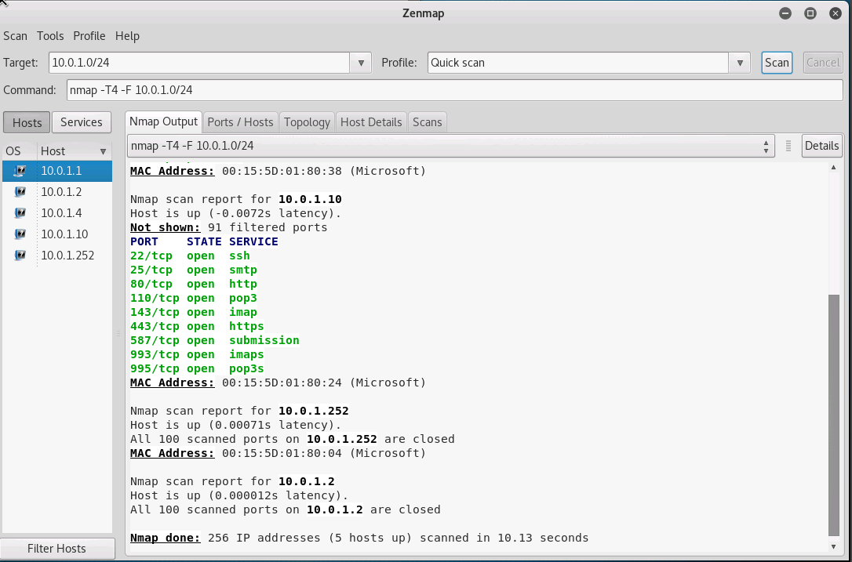

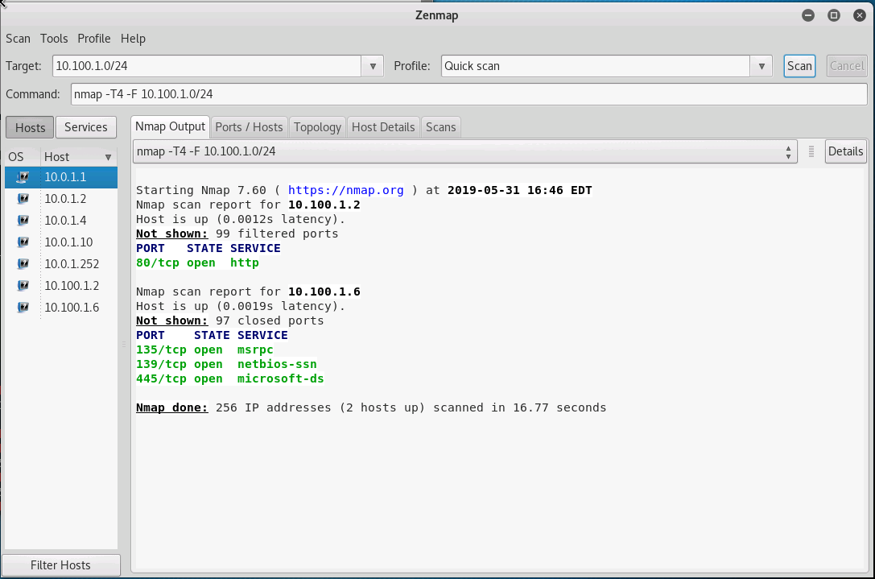

Now that you've identified the active hosts on your network, open **Wireshark** and begin capturing on the **eth0** interface. Instantly, you'll notice a large portion of the traffic is from external IP addresses. You check your external firewall logs and find nothing correlating to this traffic. Strange...

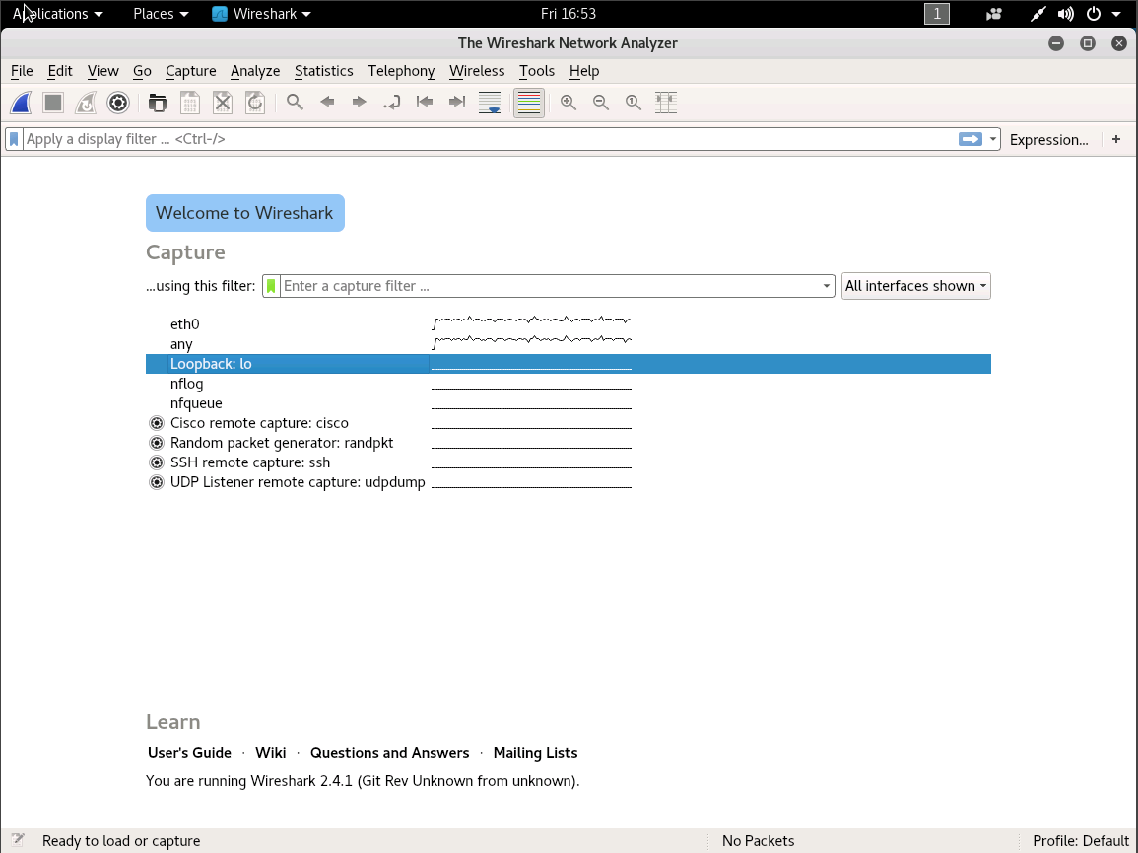

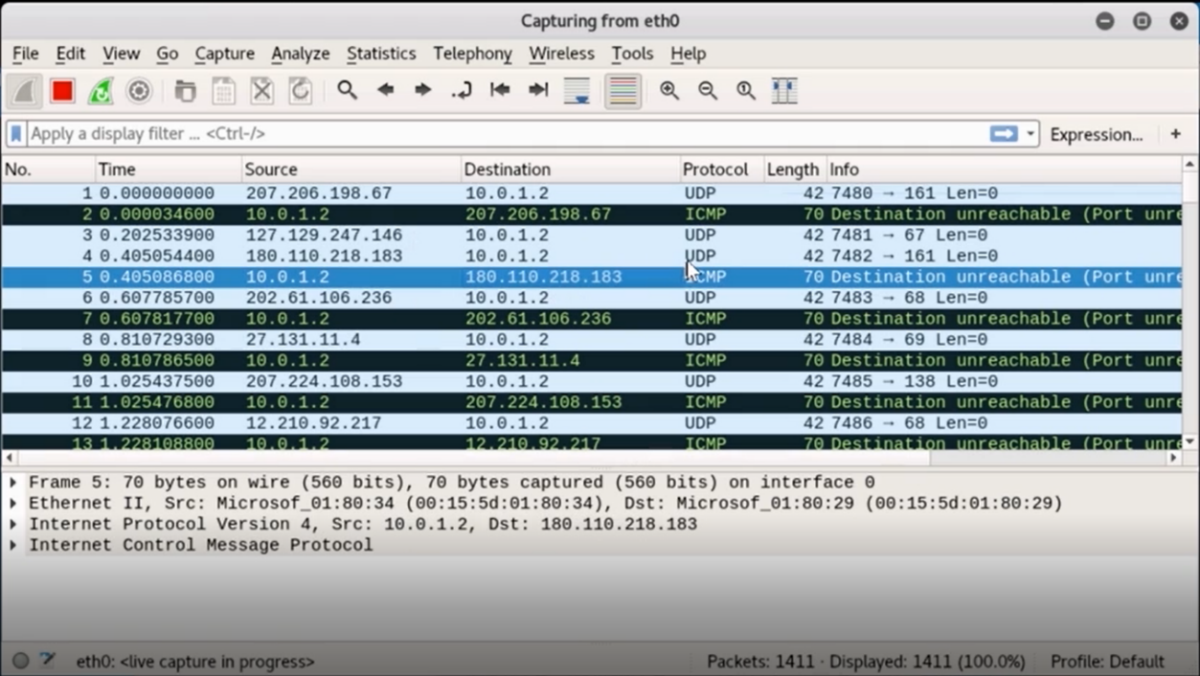

Assuming the firewall is working properly, use your Identification skills to locate the true threat inside the network. **Create a new file** on your **Desktop**, **Threat.txt**, and record the **MAC address** and **local IP address** of the device responsible for slowing down the network connection. **HINT:** The command "sudo arp -n" may help in mapping addresses to a device.

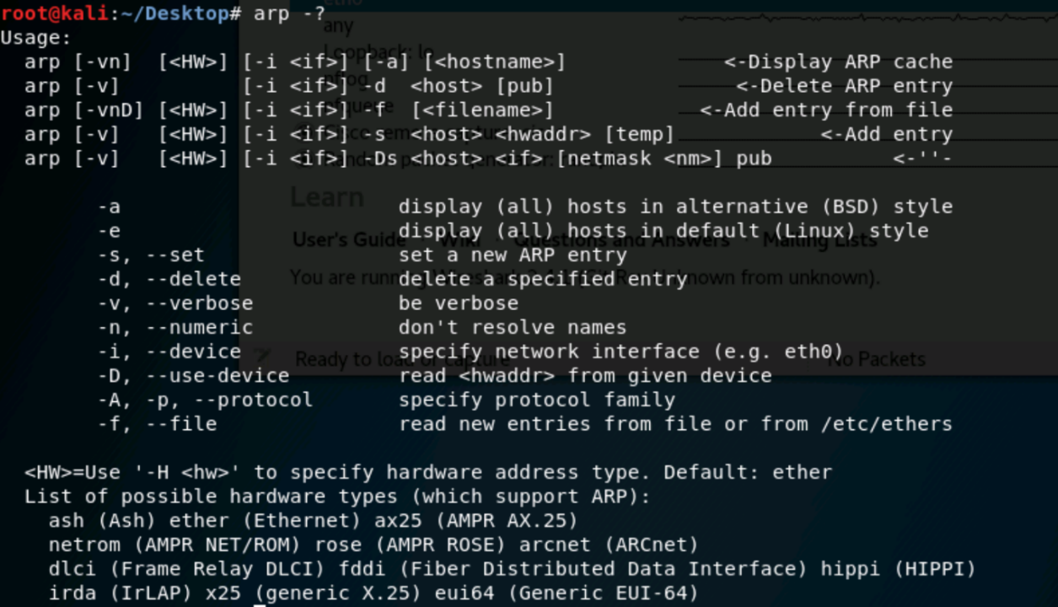

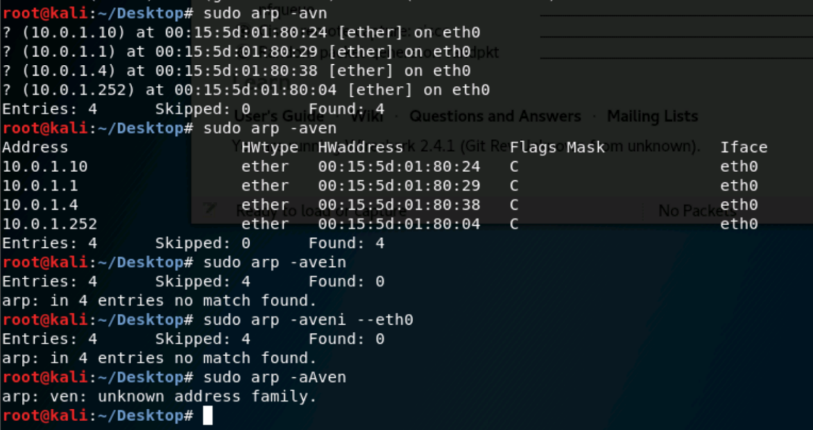

10.0.1.252 uses the same MAC address as 10.0.1.2

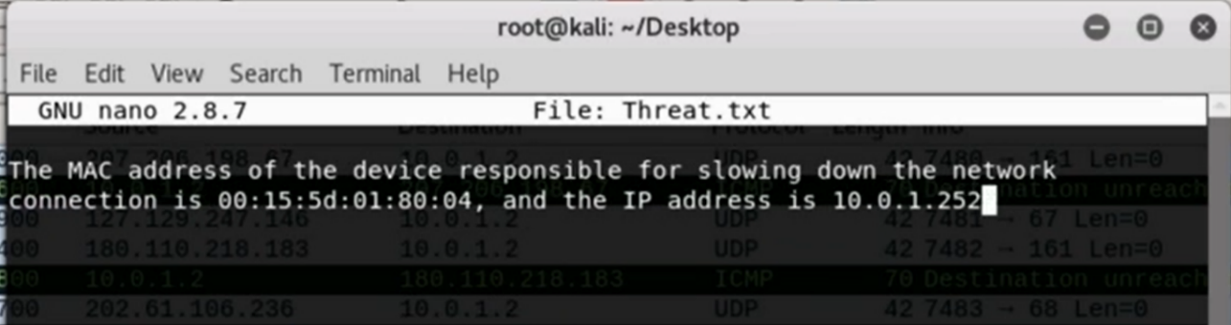

# 03 FIREWALL SETUP

|  |  |
| --- | --- |
| TASK | KEY PERFORMANCE INDICATORS |
| Ran MYSQL Test | **K0023**: Knowledge of database management systems, query languages, table relationships, and views |
| Created HTTP Web Browsing Rules | **K0049:** Knowledge of information technology (IT) security principles and methods (e.g., firewalls, demilitarized zones, encryption).  **K0487**: Knowledge of network security (e.g., encryption, firewalls, authentication, honey pots, perimeter protection).  **S0076**: Skill in configuring and utilizing software-based computer protection tools (e.g., software firewalls, antivirus software, anti-spyware).  **S0084:** Skill in configuring and utilizing network protection components (e.g., Firewalls, VPNs, network intrusion detection systems). |
| Created HTTPS Web Browsing Rules | **K0049: Knowledge of information technology (IT) security principles and methods (e.g., firewalls, demilitarized zones, encryption).**  **K0487: Knowledge of network security (e.g., encryption, firewalls, authentication, honey pots, perimeter protection).**  **S0076: Skill in configuring and utilizing software-based computer protection tools (e.g., software firewalls, antivirus software, anti-spyware).**  **S0084: Skill in configuring and utilizing network protection components (e.g., Firewalls, VPNs, network intrusion detection systems).** |
| Created Rules for Mail Server | **S0084: Skill in configuring and utilizing network protection components (e.g., Firewalls, VPNs, network intrusion detection systems).**  **S0076: Skill in configuring and utilizing software-based computer protection tools (e.g., software firewalls, antivirus software, anti-spyware).**  **K0487: Knowledge of network security (e.g., encryption, firewalls, authentication, honey pots, perimeter protection).**  **K0049: Knowledge of information technology (IT) security principles and methods (e.g., firewalls, demilitarized zones, encryption).** |
| Created rules for External Web Server Access | **K0049: Knowledge of information technology (IT) security principles and methods (e.g., firewalls, demilitarized zones, encryption).**  **K0487: Knowledge of network security (e.g., encryption, firewalls, authentication, honey pots, perimeter protection).**  **S0076: Skill in configuring and utilizing software-based computer protection tools (e.g., software firewalls, antivirus software, anti-spyware).**  **S0084: Skill in configuring and utilizing network protection components (e.g., Firewalls, VPNs, network intrusion detection systems).** |
| Create rules for MySQL Access | **S0084: Skill in configuring and utilizing network protection components (e.g., Firewalls, VPNs, network intrusion detection systems).**  **S0076: Skill in configuring and utilizing software-based computer protection tools (e.g., software firewalls, antivirus software, anti-spyware).**  **K0487: Knowledge of network security (e.g., encryption, firewalls, authentication, honey pots, perimeter protection).**  **K0049: Knowledge of information technology (IT) security principles and methods (e.g., firewalls, demilitarized zones, encryption).** |

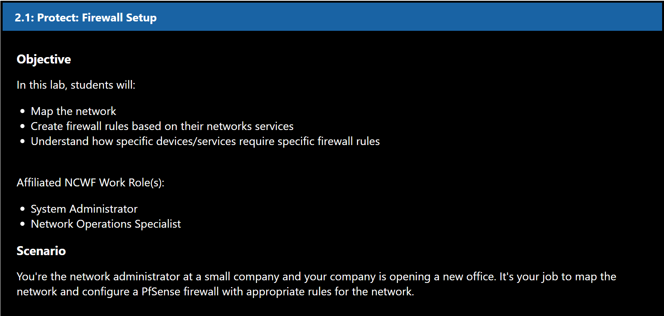

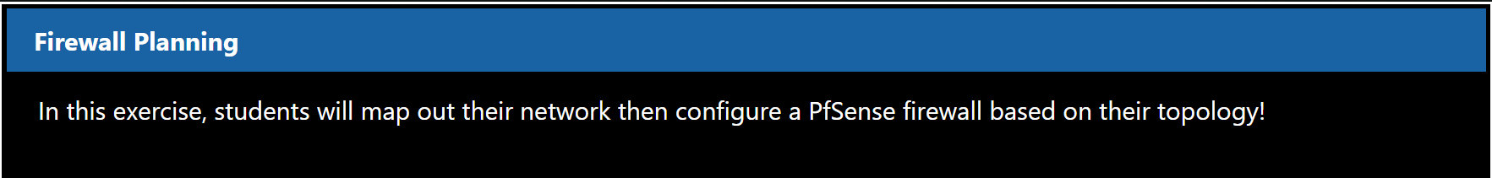

## 3.1 Firewall Planning

### 3.1.1 Mapping the Network

Before we begin writing our rules, we need to identify each device on our network. This will enable us to create specific rules for certain devices on the network. Highlight the Machines tab on the right of your screen. Select the Wordpress Web Server machine.

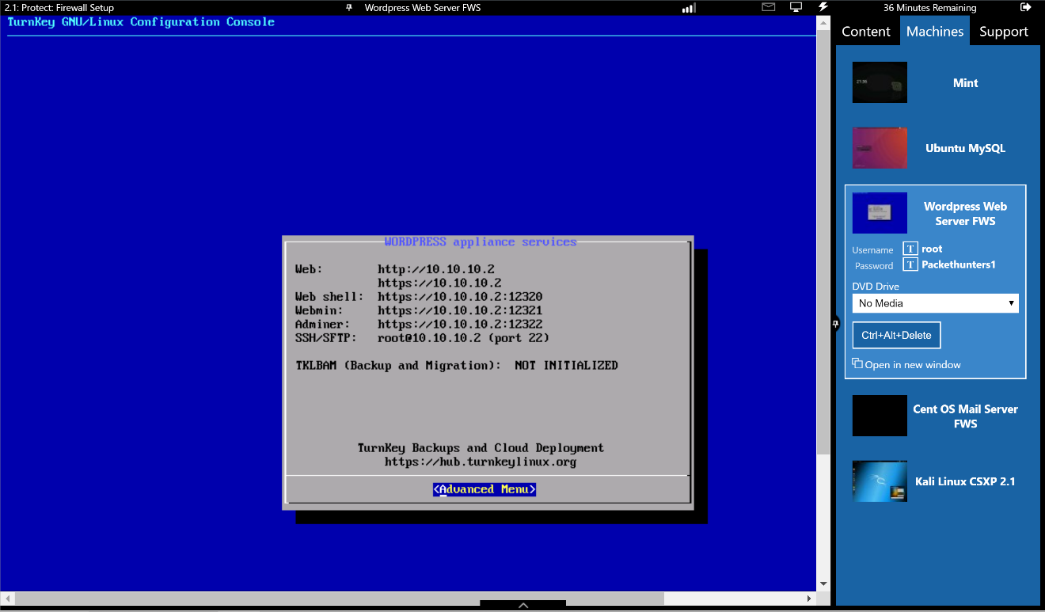

### 3.1.2 Network Mapping: Web Server

In the appliance services menu, we can see this Web Server has an IP of **10.10.10.2**. This segment, **10.10.10.0/24**, is the DMZ segment. Since we want our web server to be accessible by anyone one the Internet, we will have to create firewall rules allowing HTTP and HTTPS requests through the firewall.

### 3.1.3 Network Mapping: Mail Server

Switch to the **Cent OS Mail Server**. Login with the username **root** and password **packethunters**. Once logged in, perform an **ifconfig**. The mail server should have an IP of **10.0.1.2**, indicating it's on the LAN. This means we won't have to create any firewalls rules allowing employee access, because the employee computers are also on the LAN. However, we will have to create a rule allowing inbound mail to the server's IP.

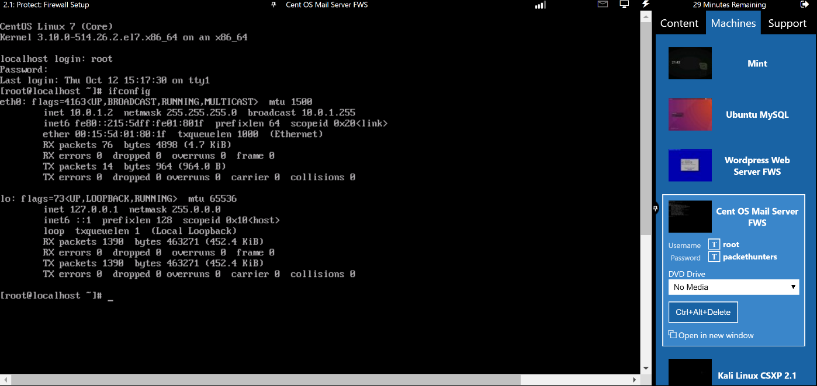

### 3.1.4 Network Mapping: MySQL Server

Finally, switch to the **Ubuntu MySQL machine**. Running on this machine is a MySQL Database, which is used by the Web Server. Open a terminal and check the IP of the database by entering **ifconfig**. It should have a static address of **10.10.10.99**. Next, make sure the Web Server is active by executing "**sudo /etc/init.d/mysql status**”. Enter **packethunters** when prompted for a password.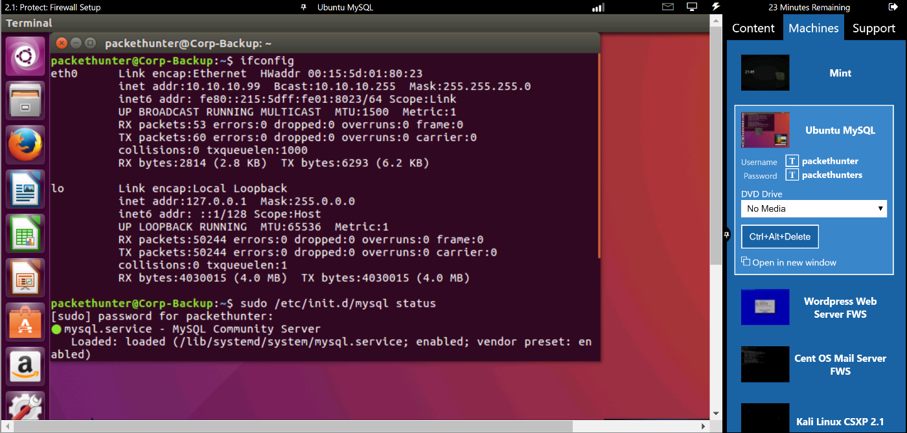".

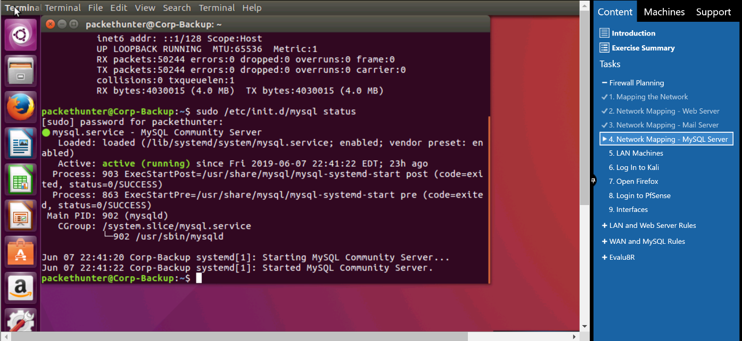

### 3.1.5 LAN Machines

The remaining machine, **Linux Mint**, is part of our LAN segment. We will be using Kali, which is also on the LAN, to write firewall rules, so any rules we create for the LAN segment will also apply to the Mint Machine.

### 3.1.6 Login to Kali

Now that we know our networks layout, begin creating firewall rules! Log in to the **Kali VM** with the username root and password isaca.

### 3.1.7 Login to PfSense

Log in to the **PfSense web configurator** with the username Student and password Isaca.

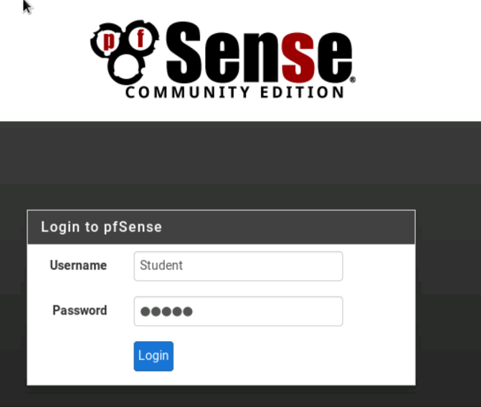

### 3.1.8 Interfaces

On the home page, locate the Interfaces tab. You should see 3 - WAN, LAN, and DMZ. During this lab, we will be configuring rules for each of these interfaces

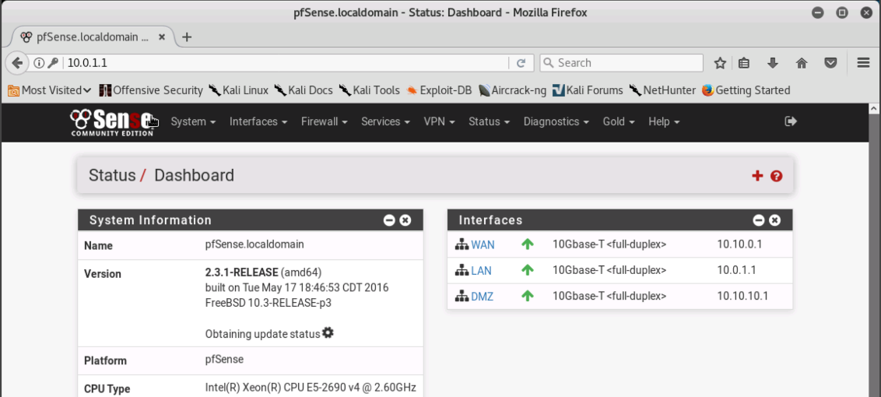

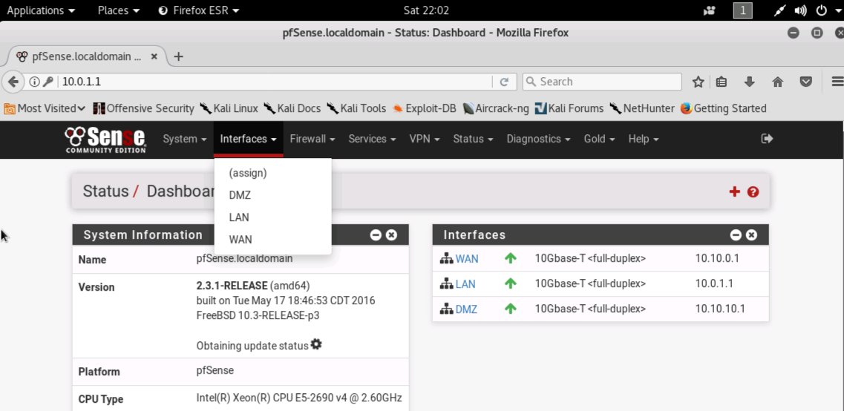

## 3.2 LAN and Web Server Rules

### 3.2.1 Firewall Rules

Firewalls incorporate rule lists, which set the criteria for determining whether a packet is passed through the firewall, or blocked. Packets are checked against rules starting at the **top of the list**, and once it finds a match, it follows that specific rule and skips the rest. So, it is a good idea to put a rule denying all traffic that doesn't match a rule. Inversely, you could also create rules looking for specific traffic to block, then put a rule allowing all traffic at the **bottom of the list**. Given the vast number of protocols and the importance of having a secure firewall, **the first method is considered much safer**. This is the method we will use for the following exercise. When creating your rules, **pay close attention to whether you are adding to the top of the list or the bottom**.

### 3.2.2 Stateful Rules

**PfSense** is a **Stateful** firewall: it monitors the operating state of its network connections. F.ex., if we write a rule allowing outbound HTTP requests through our LAN interface, after a request goes through the interface will monitor the inbound traffic looking for the response. Once it has been identified, the firewall will let it through. This is because the firewall is monitoring the state of the packet. By looking at the initial packet allowed through, the firewall can determine what the response should look like. F.ex., if the first packet is a TCP SYN request, the firewall will be looking for a TCP SYN/ACK response, with a destination IP of the first packets source address. If this were a stateless firewall, we would be required to write a matching inbound rule for every outbound rule, and vice-versa.

### 3.2.3 Safety First

Before we configure the LAN, we need to create a rule denying all traffic across the WAN and DMZ interfaces. When creating firewall rules, you can choose to "**Pass**", "**Block**", or "**Reject**" the traffic relating to that rule. "**Reject**" tells the firewall to respond to all rejected traffic with an error message. This allows for easy fingerprinting of a firewall by an attacker, because they can keep sending different types of traffic until some of it gets through. Eventually, they will be able to narrow down which traffic you are allowing through. The "**Block**" option will essentially "kill" the traffic without giving a response. This is the option we will be using. On the **PfSense web GUI**, click the **Firewall** tab and select **Rules**.

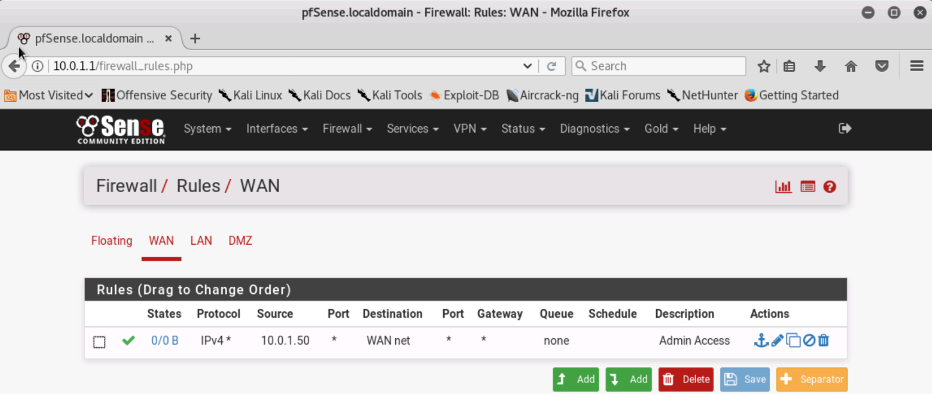

### 3.2.4 Blocking all WAN traffic

With the WAN interface underlined, add a new rule to the bottom of the list by clicking the green **add** button with an **arrow pointing down**. In Action, select **Block**. For the address family, select **IPv4+IPv6**. For protocol, select any. Under Description, enter **Deny All WAN Traffic**. Scroll down to the bottom of the page and hit Save. On the next page, hit **Apply Changes**.

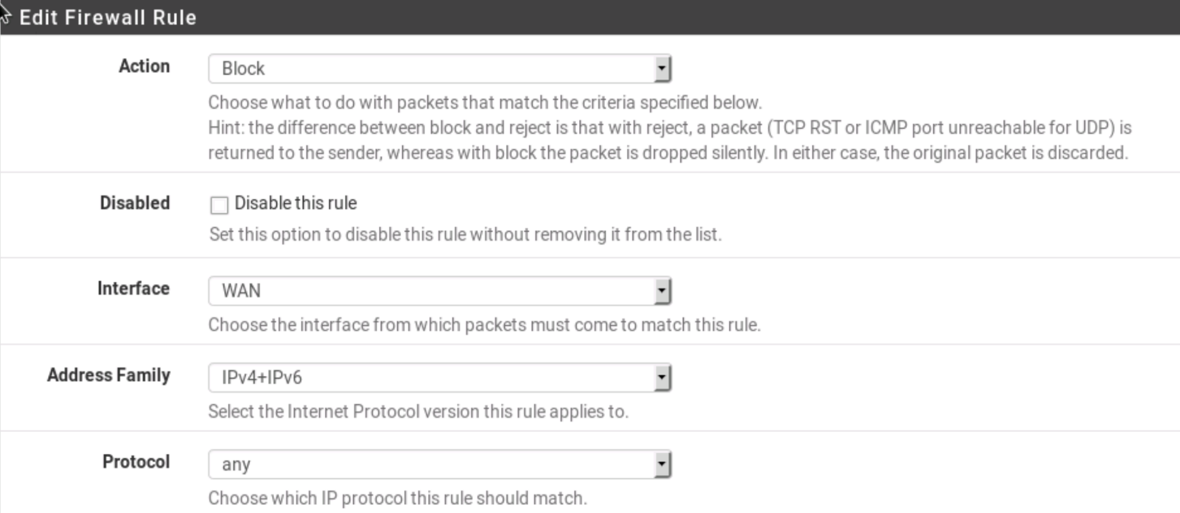

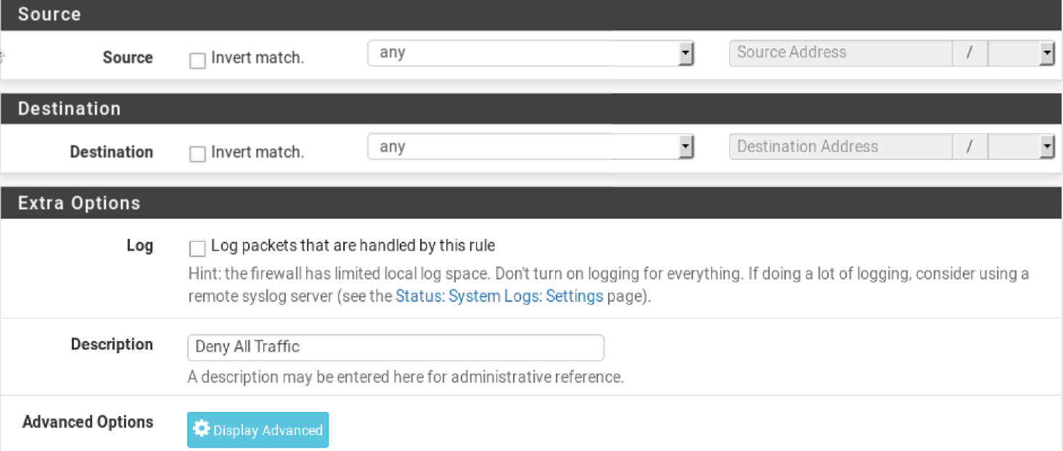

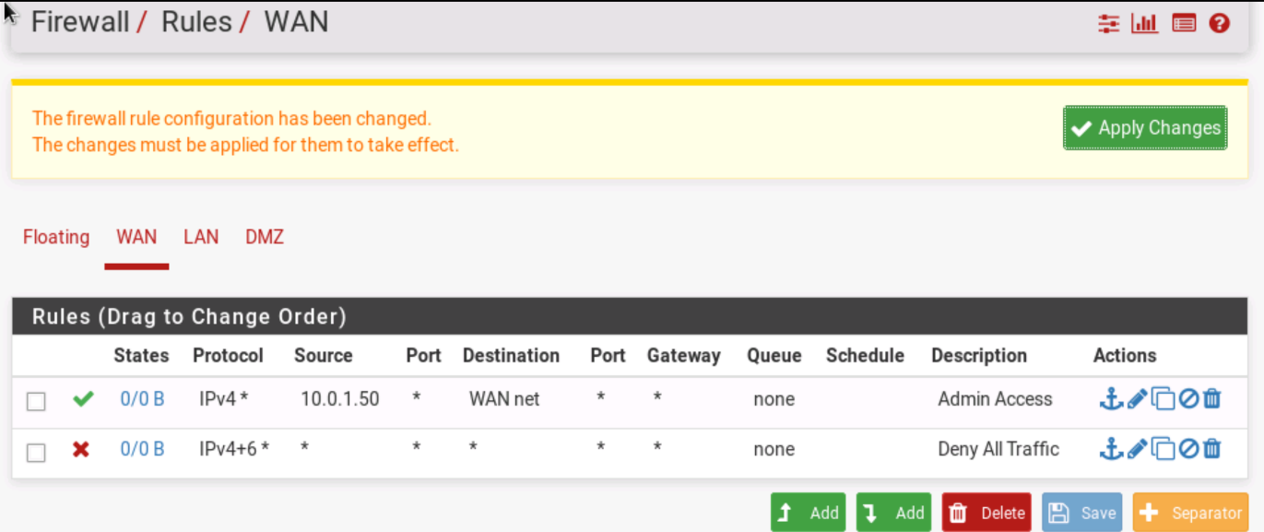

### 3.2.5 Blocking DMZ traffic

Back under the Firewall Rules menu, select the **DMZ interface**. Click the green **add** button with an arrow pointing **down**. Under **Action**, select **Block**. For the address family, select **IPv4+IPv6**. For protocol, select **any**. Under **Description**, enter **Deny All DMZ Traffic**. At the bottom of the page, hit **Save**, then **Apply Changes**.

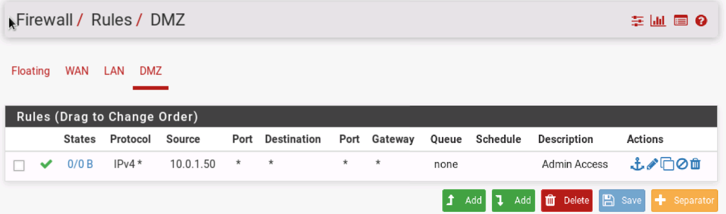

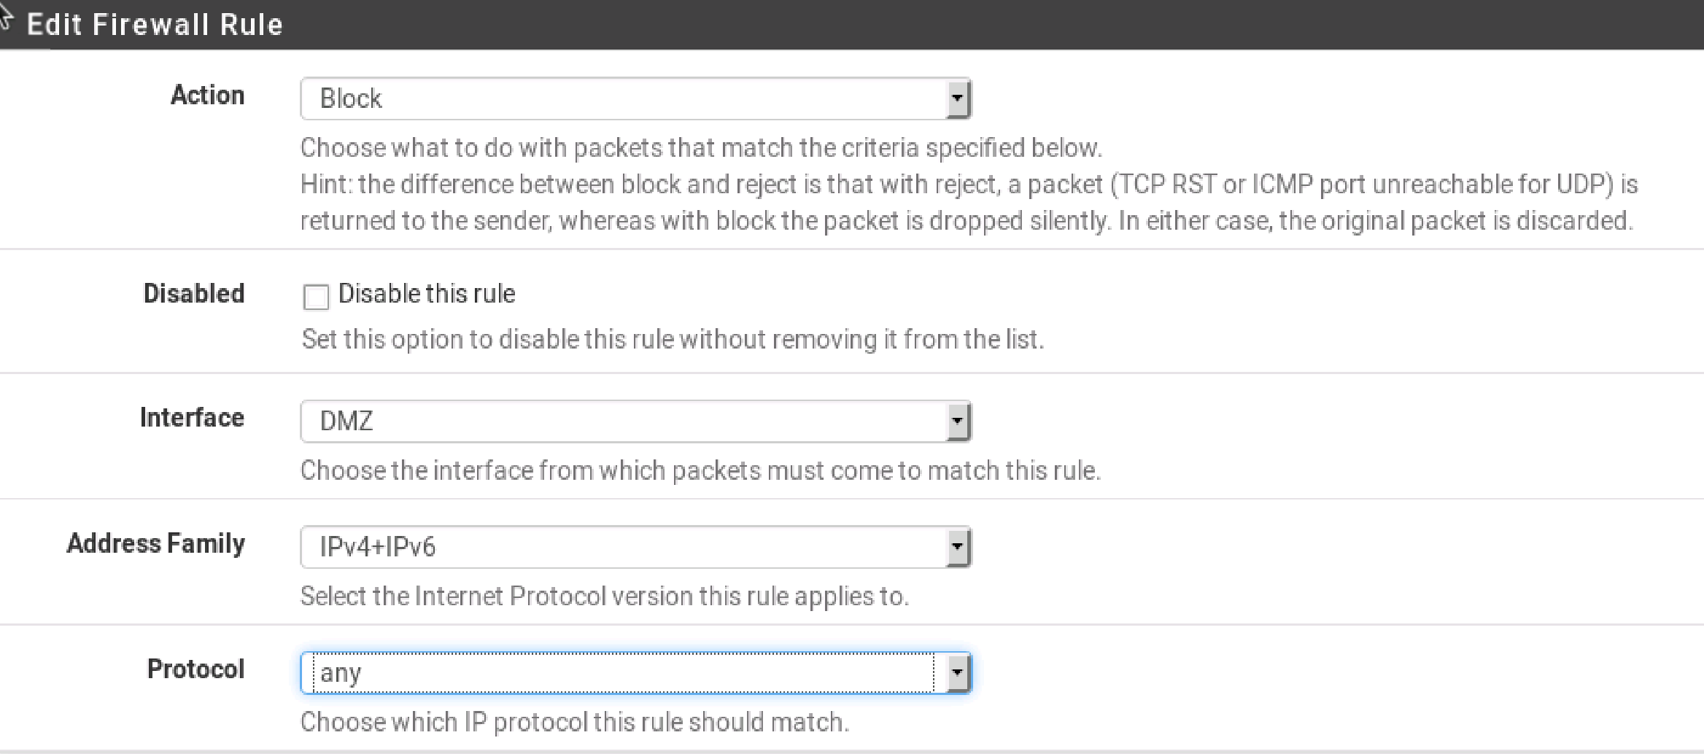

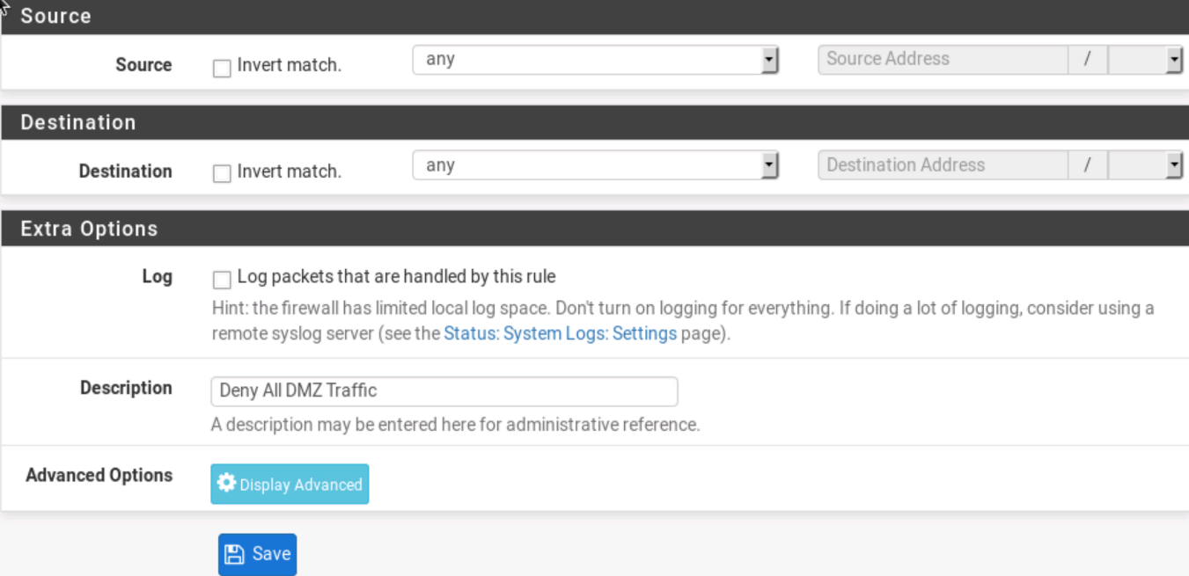

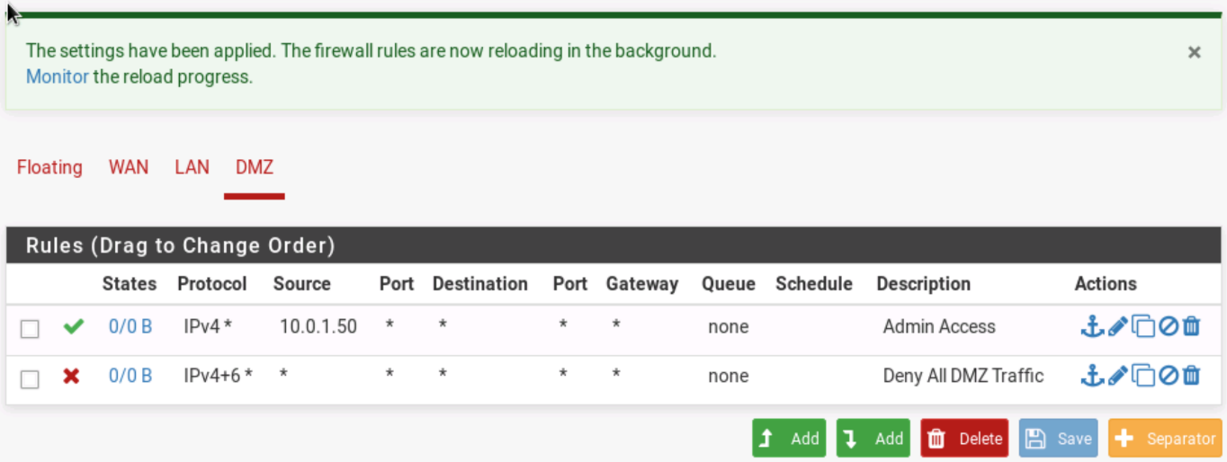

### 3.2.6 Configure the LAN

Back on the rules page, select the **LAN** interface. Then click the green add button with an arrow pointing up.

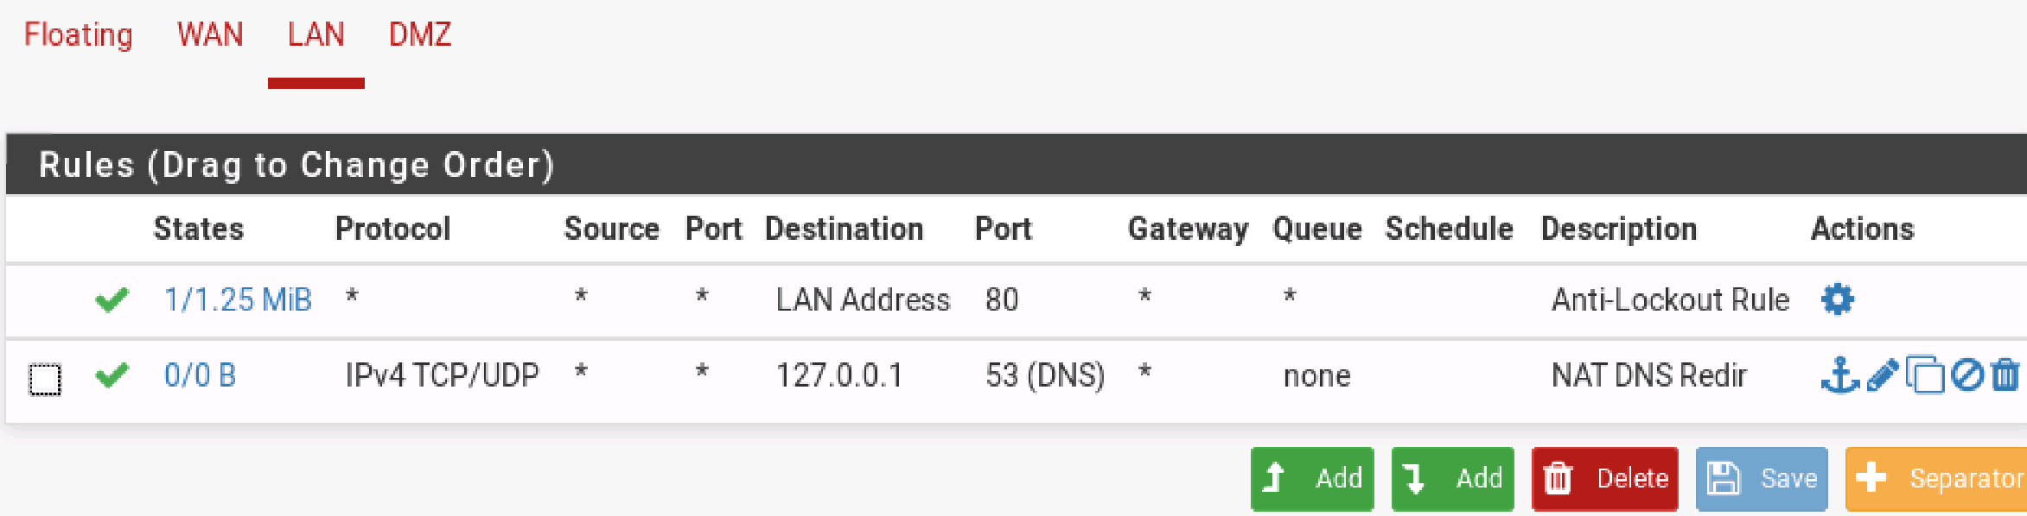

### 3.2.7 Allow outbound HTTP

On the **Add** rule page, make sure the **Action** is **Pass**, **Address Family** is **IPv4,** and **Protocol** is **TCP** (the defaults). Select **LAN Net** for the source address, and select destination port **HTTP (80)** for the destination port. Under **Description**, enter **Employee Web Browsing (HTTP).** Hit **save**, then **apply changes**. This rule will allow employees on the LAN to browse the web.

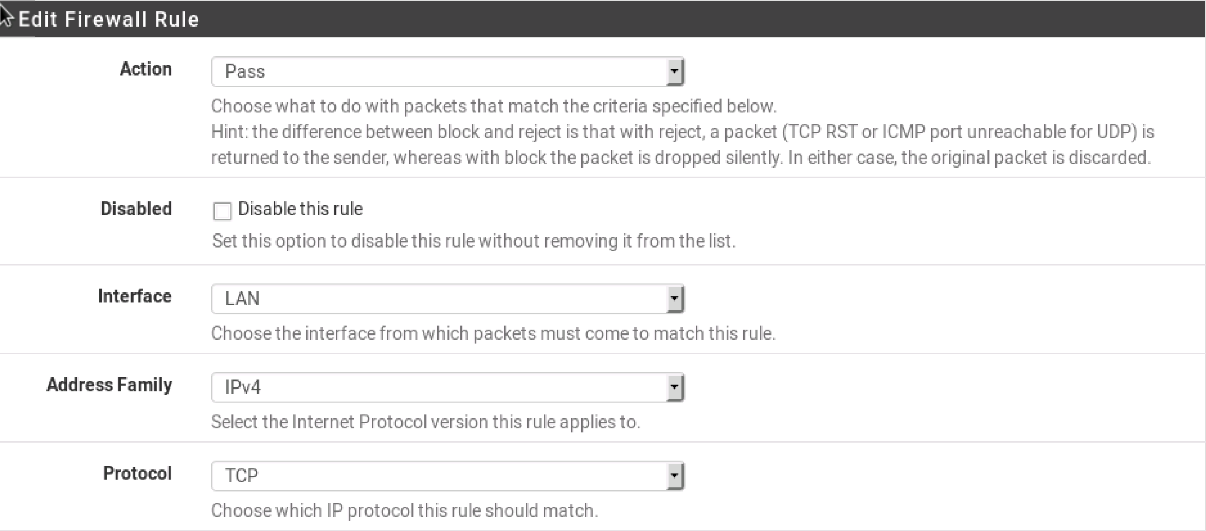

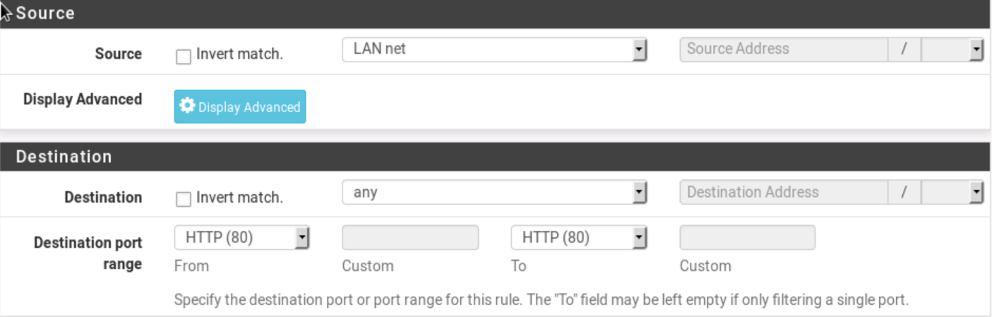

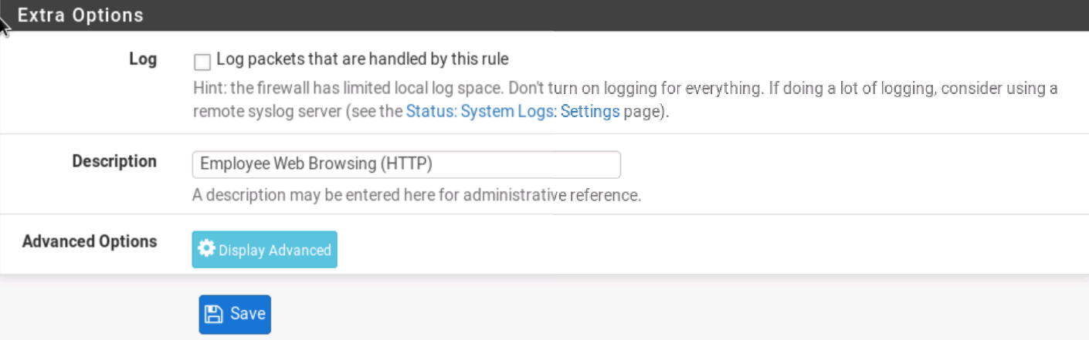

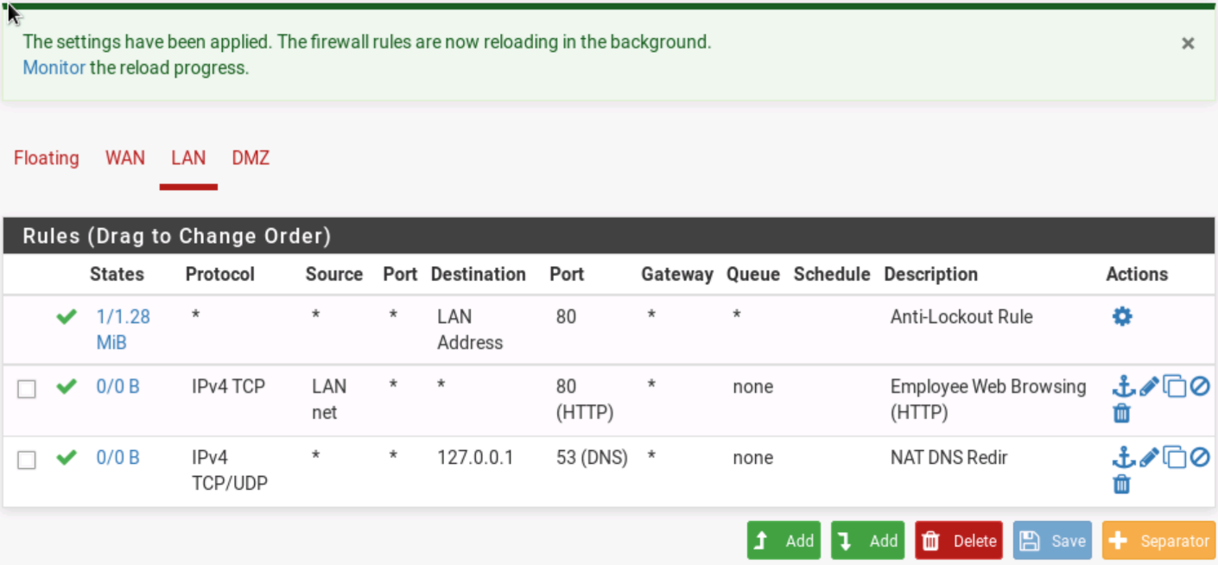

### 3.2.8 Allow outbound HTTPS

Following the same instructions as the last step, create another LAN rule allowing for **IPv4+IPv6 HTTPS** access from IP's sourced within the **LAN Net**, with a destination port of **HTTPS (443).** For description, enter **Employee Web Browsing (HTTPS)**. Hit **Save**, then **Apply changes**.

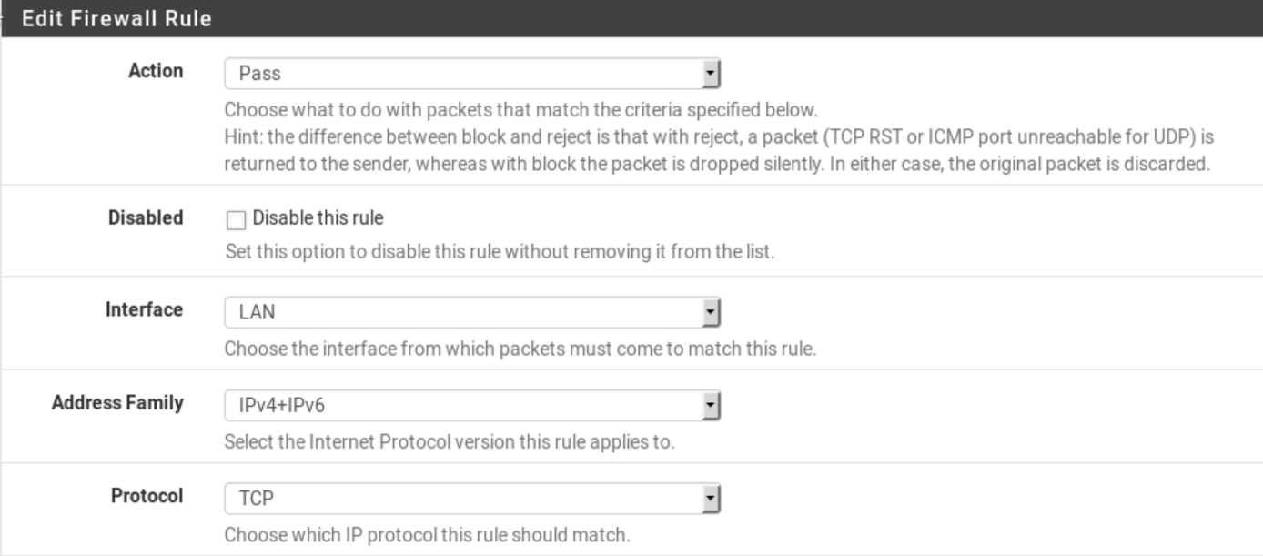

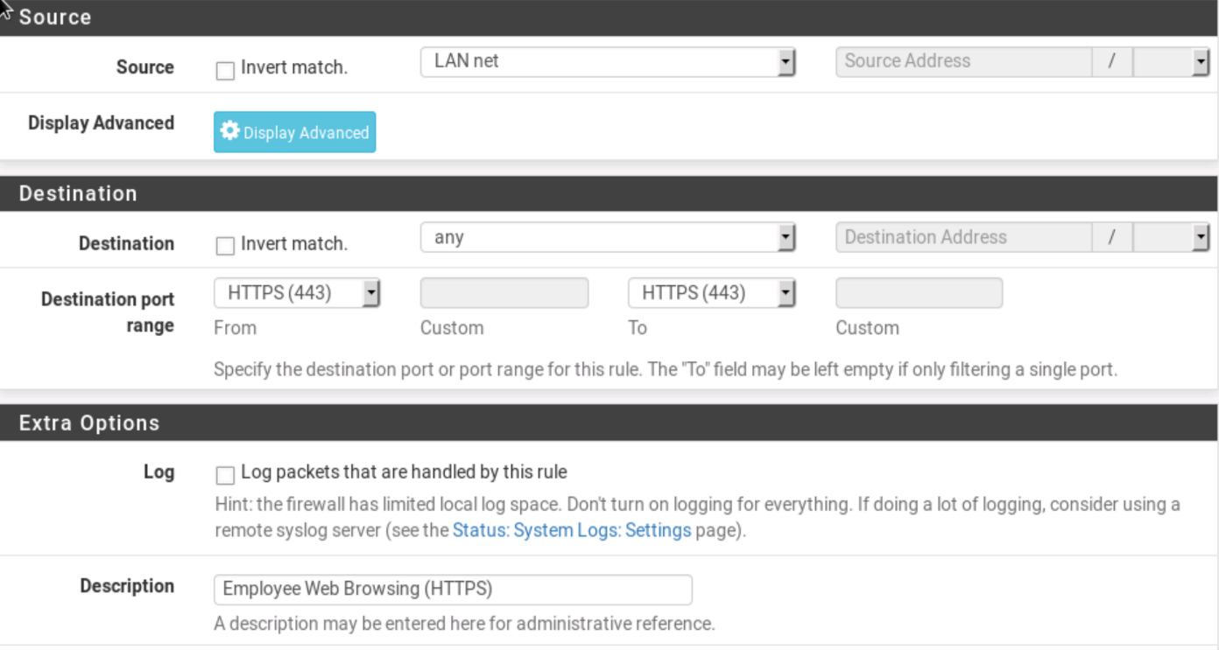

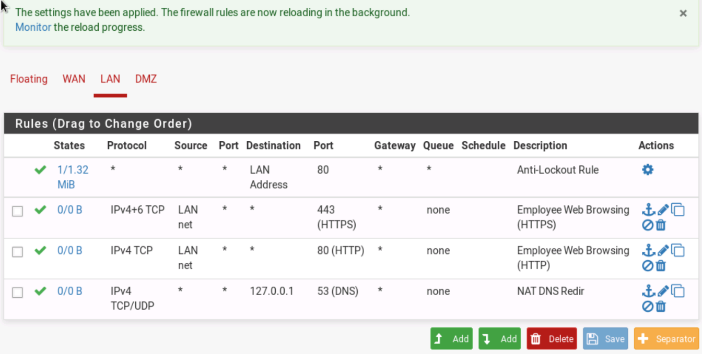

### 3.2.9 Allow Mail Server Traffic

Next we will write a rule to allow our mail sever to receive messages using SMTP Secure. This protocol will be used by our mail server for the secure transfer of messages. Select the **add** button with an arrow pointing up on the LAN interface. Under Destination, select **Single host or Alias**. For the destination address, enter the Mail Server IP address of **10.0.1.2**. For the destination port range, select **SMTP/S (465).** Finally, enter the description **SMTP/S** to Mail Server.

Hit **Save**, then **apply changes**.

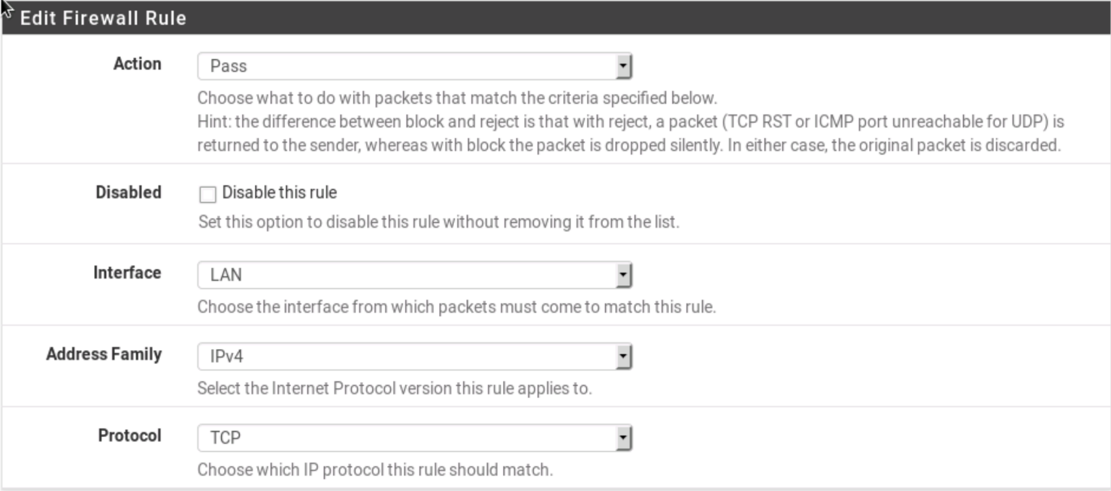

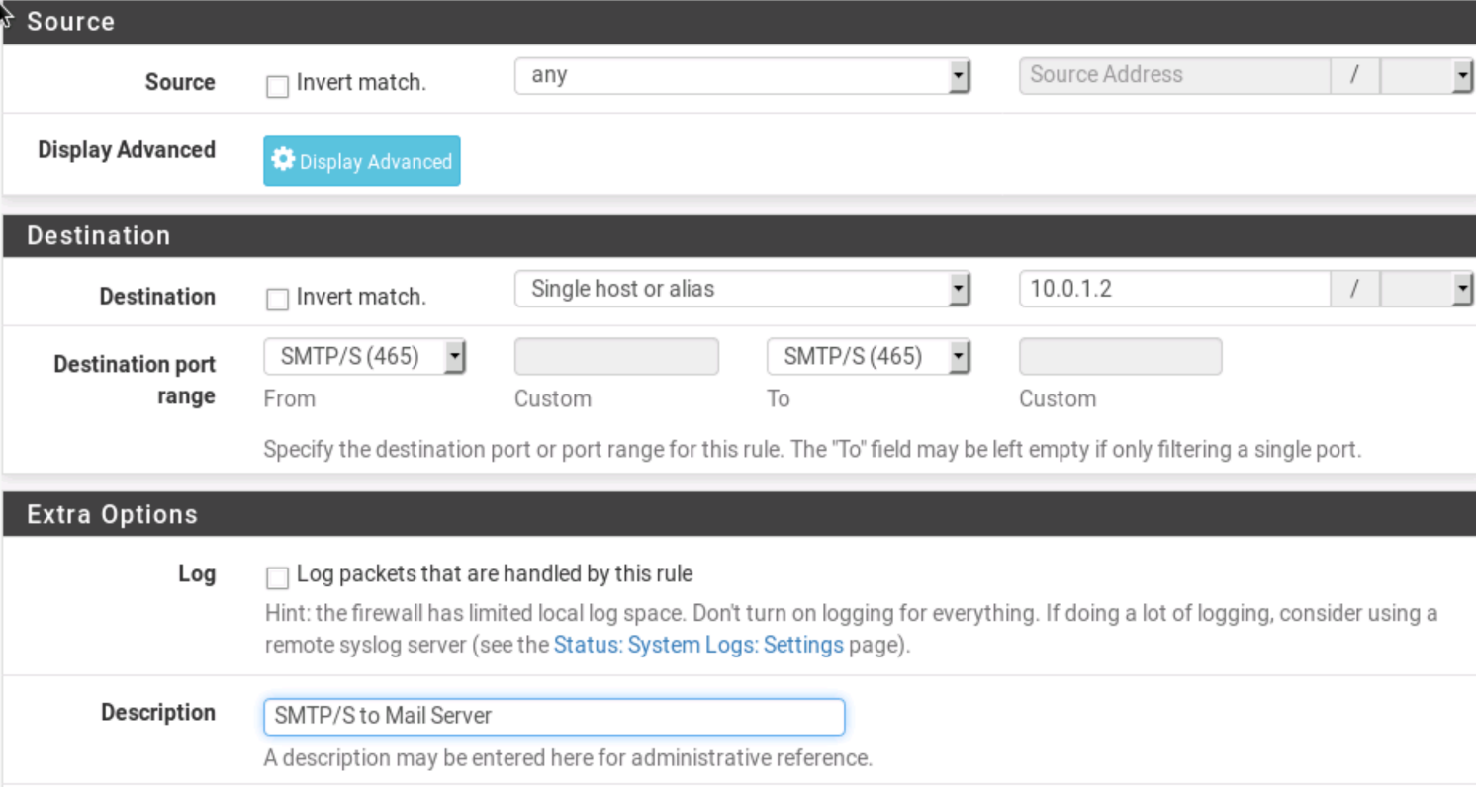

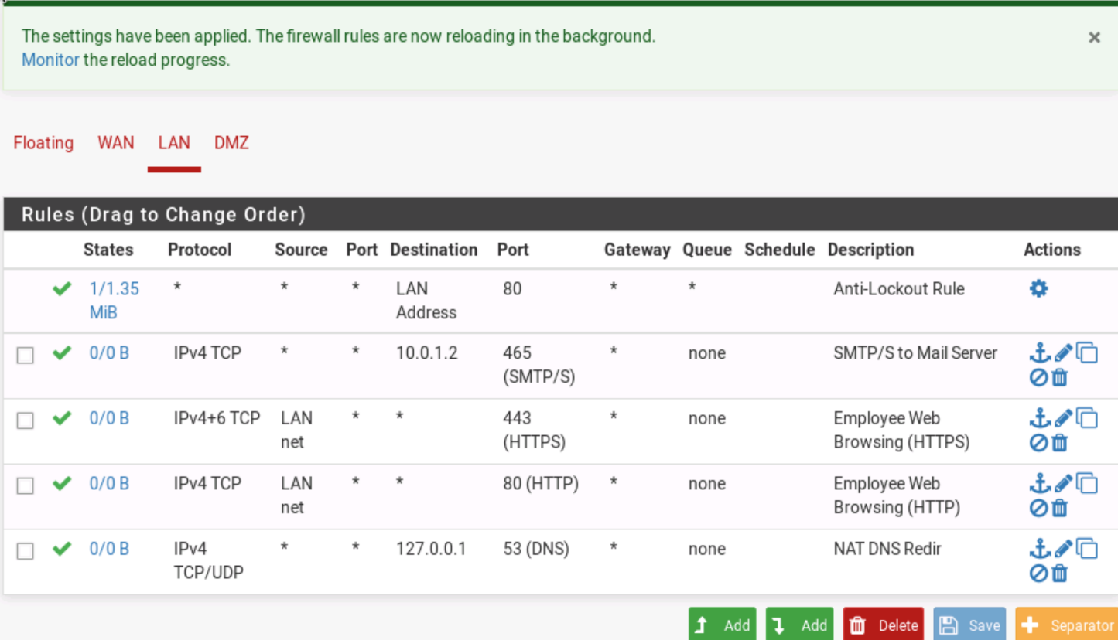

### 3.2.10 DMZ Rules

Next, we will write a rule for the Web Server in the DMZ. Under **Firewall Rules**, select **DMZ**, then select the **Add** button with an arrow pointing up. Under destination, select **Single host or alias**, and enter the Web Server IP of **10.10.10.2**. Our server uses HTTPS, so under destination port range, select **HTTPS (443).** This rule will give anyone on the Internet HTTPS access to our Web Server. Enter "**External Web Server Access**" in the description. Hit **Save,** then **apply changes**.

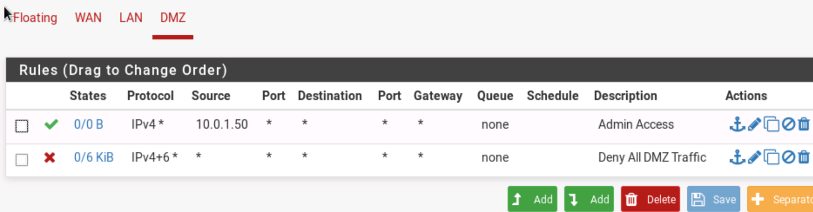

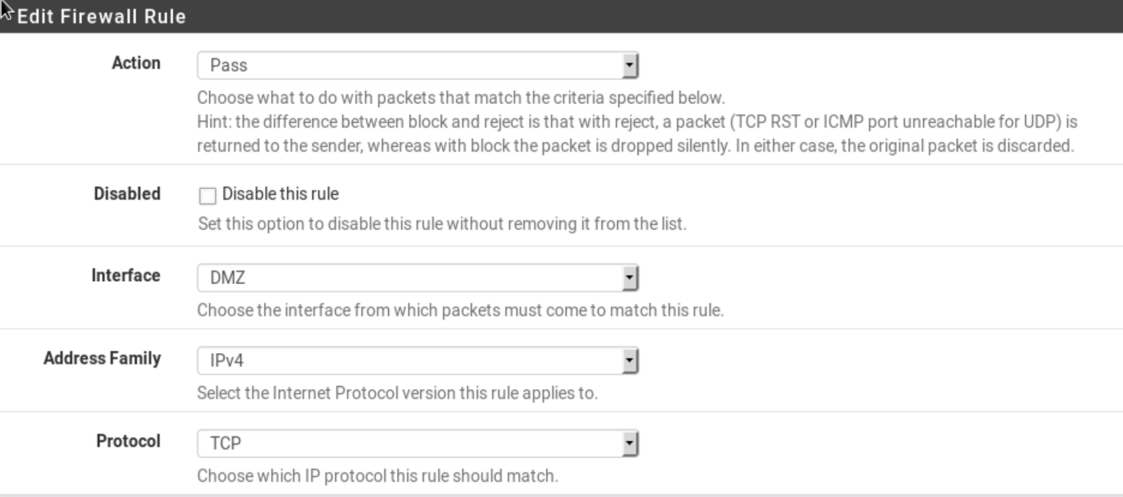

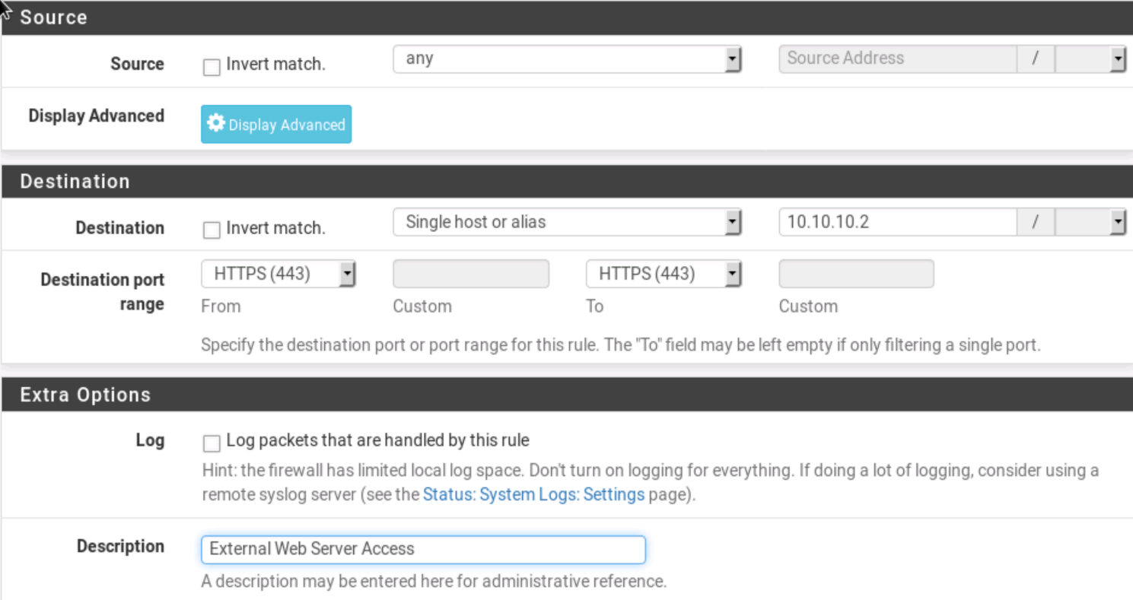

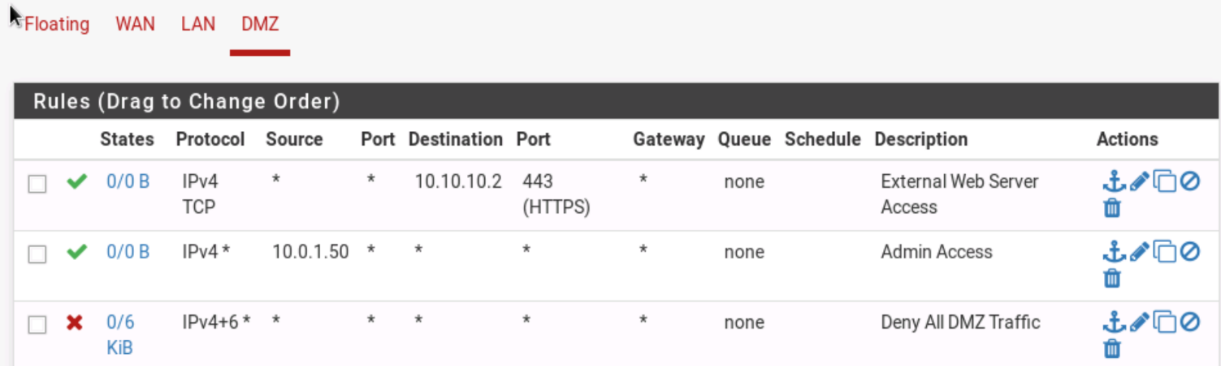

## 3.3 WAN and MySQL Rules

### 3.3.1 Configure WAN

From the interfaces drop-down menu, select **WAN**. Scroll down to the bottom of the page where it says **Reserved Networks.**

### 3.3.2 Block reserved networks

Check the boxes for "**Block private networks and loopback addresses**" and "**Block bogon networks**", and hit **Save**. The first option will tell our firewall to block inbound traffic from private networks and loopback addresses. Certain IP's are assigned for internal networks, just like our 10.0.1.0/24 network. These IP's are not publicly routable, so if the WAN interface receives an inbound packet with a private source IP and destination IP inside our network, it means it is being spoofed. Otherwise, the packet would have had no way of being routed to our address. The second blocks traffic from IP's that have not been assigned by IANA. Technically these IP's don't exist, as they have not been authorized to be publicly routable. Once again, if we receive a packet with one of these IP's as a source address, it is safe to assume it is malicious.

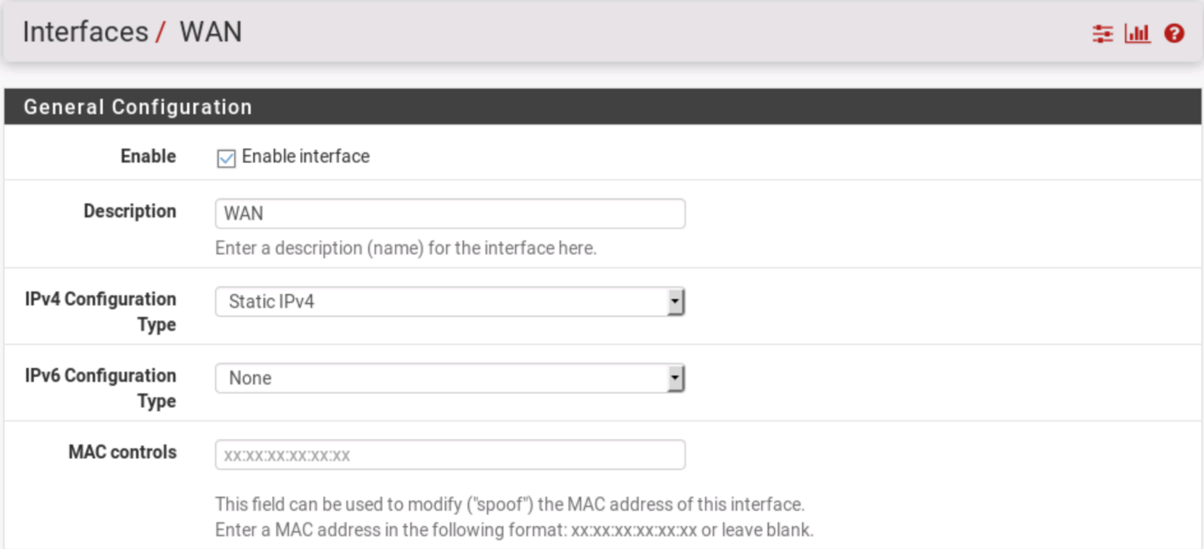

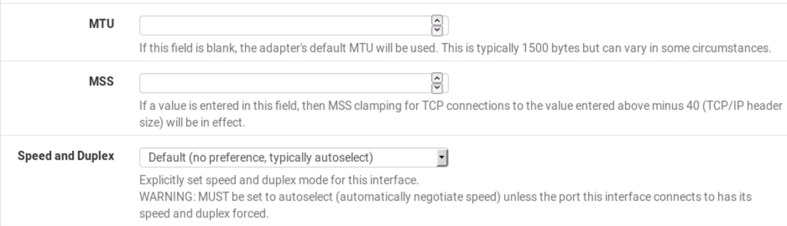

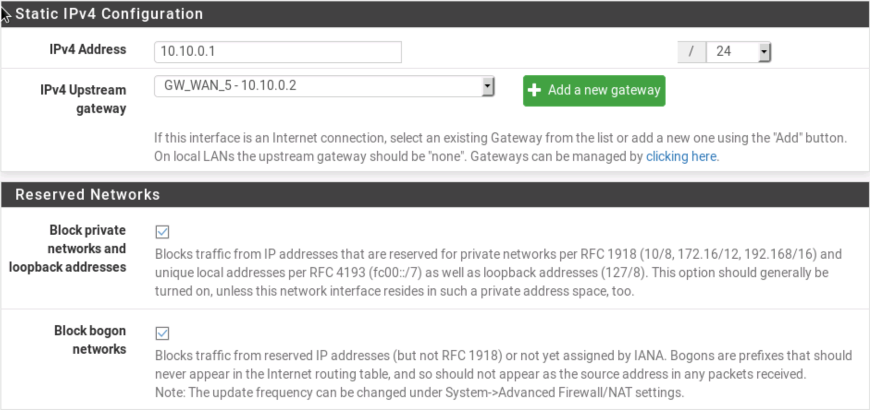

### 3.3.3 Firewall Rules List

Hit **Apply Changes**. Then click the Firewall drop-down menu, and select **Rules**. Click **WAN**. You should see two new rules at the top of the list - Block private networks, and Block bogon networks.

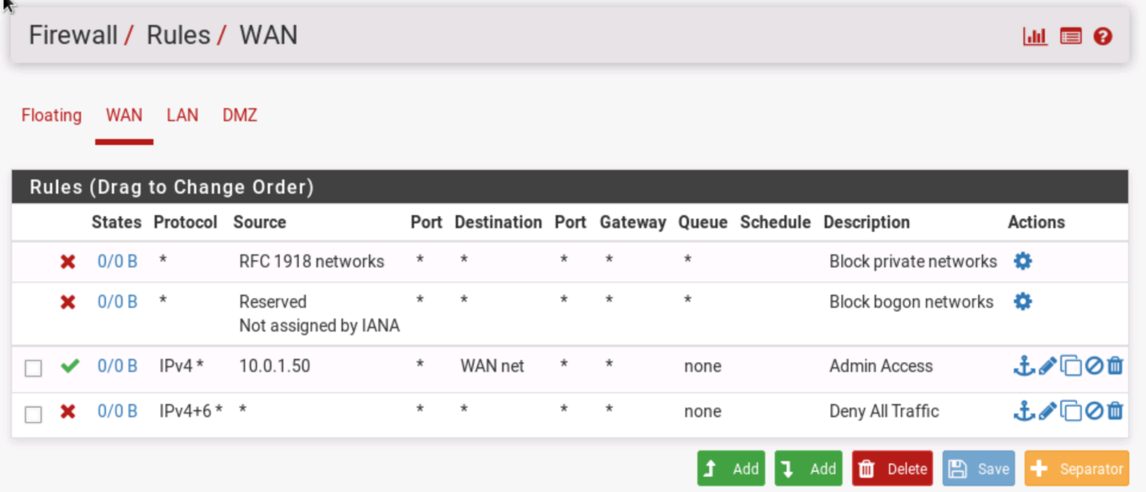

### 3.3.4 HTTP WAN Rules

At the bottom of the page, select the **Add** button with the **upward** facing arrow. We need to add rules to match the LAN rules. Even though the firewall is stateful, the WAN interface is not aware of the LAN's rules. This means it needs its own rules in order to identify which stateful connections to allow. Under **Protocol**, select **TCP**. Change the source to **LAN Net**. Change the destination port to **port 80**. Enter in the description "**Employee Web Browsing (HTTP)".** Hit Save, then Apply Changes on the next page.

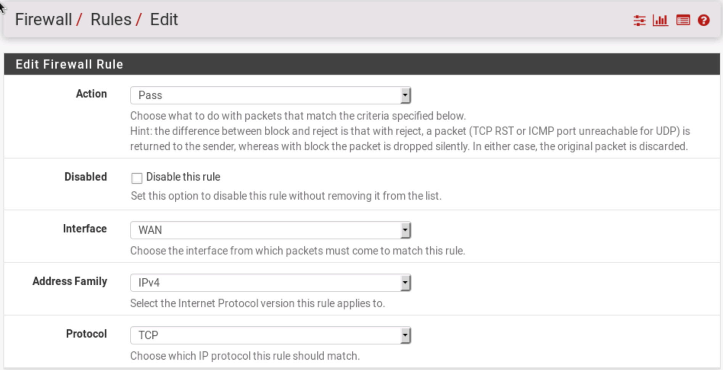

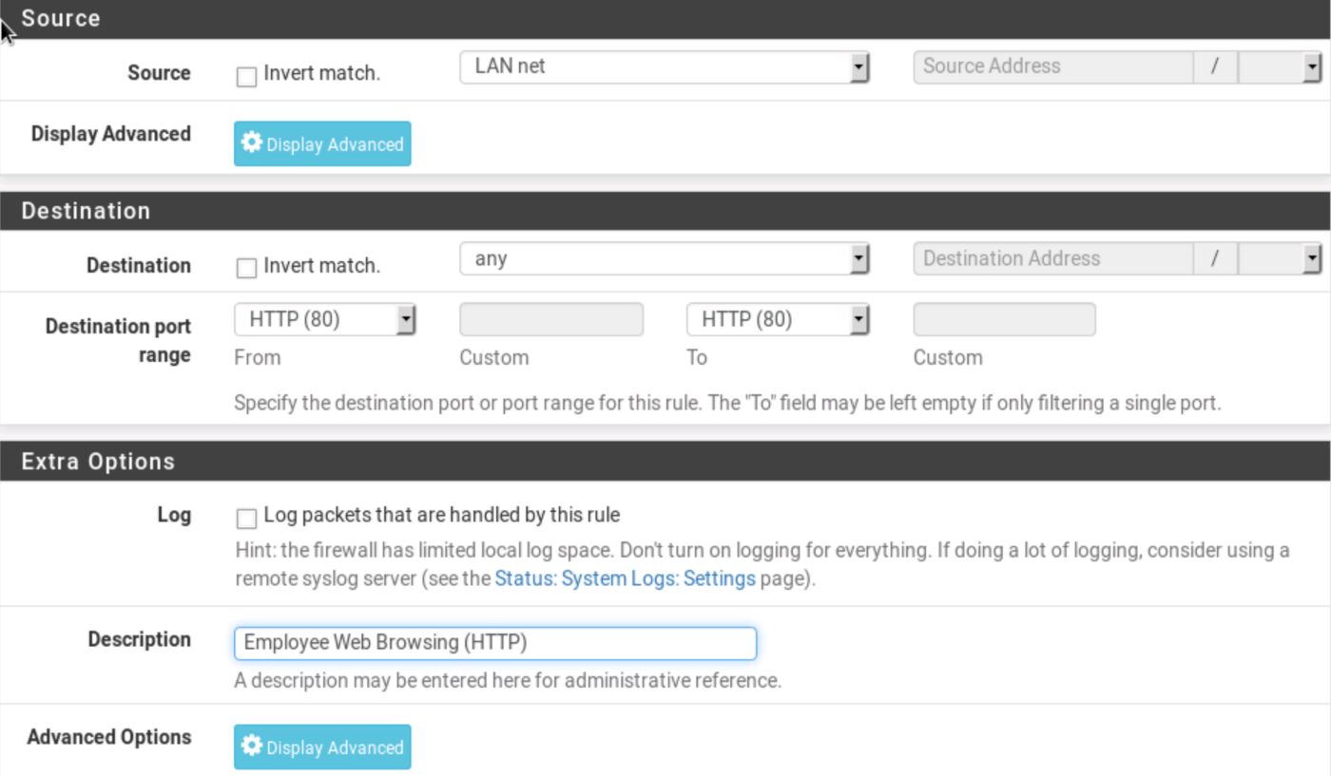

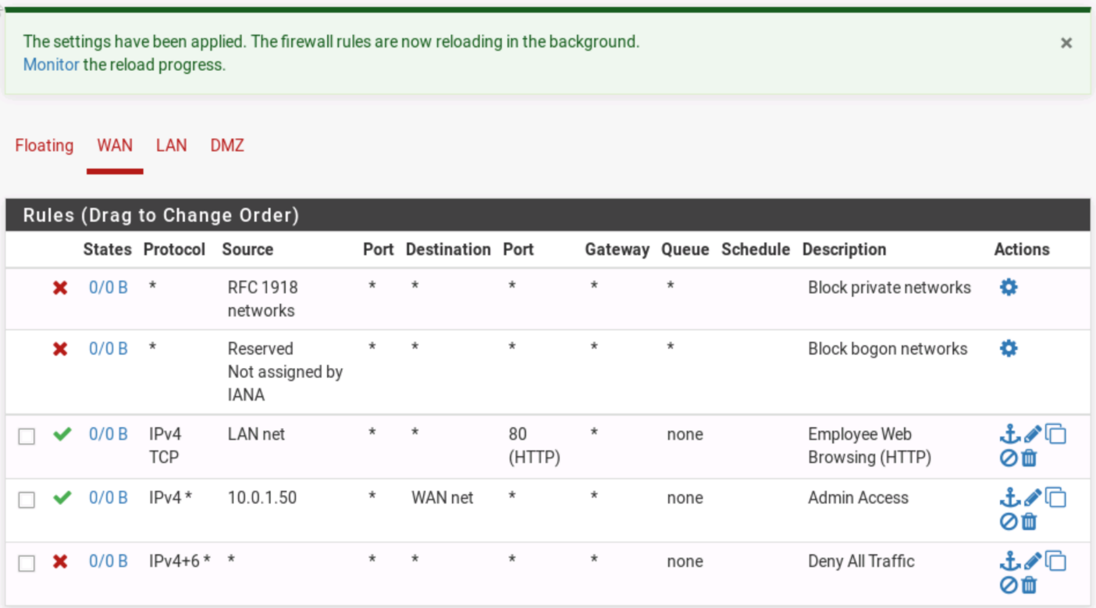

### 3.3.5 HTTPS WAN Rules

Select the green **Add** button with an upward facing arrow. Under protocol, select **TCP**. Under source, select **LAN Net**. Under destination port, select **443**. Enter "**Employee Web Browsing (HTTPS)"** in Description. Hit Save, Apply Changes.

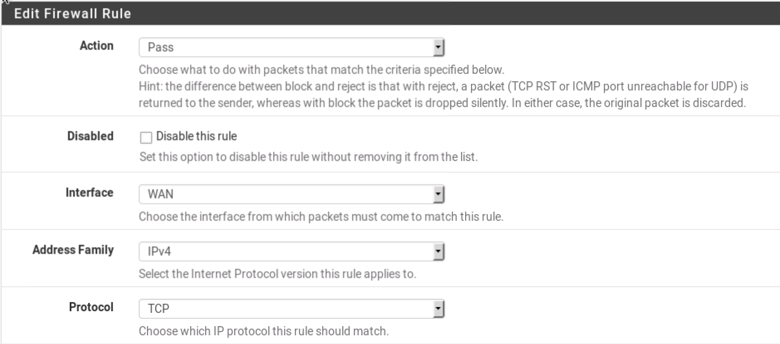

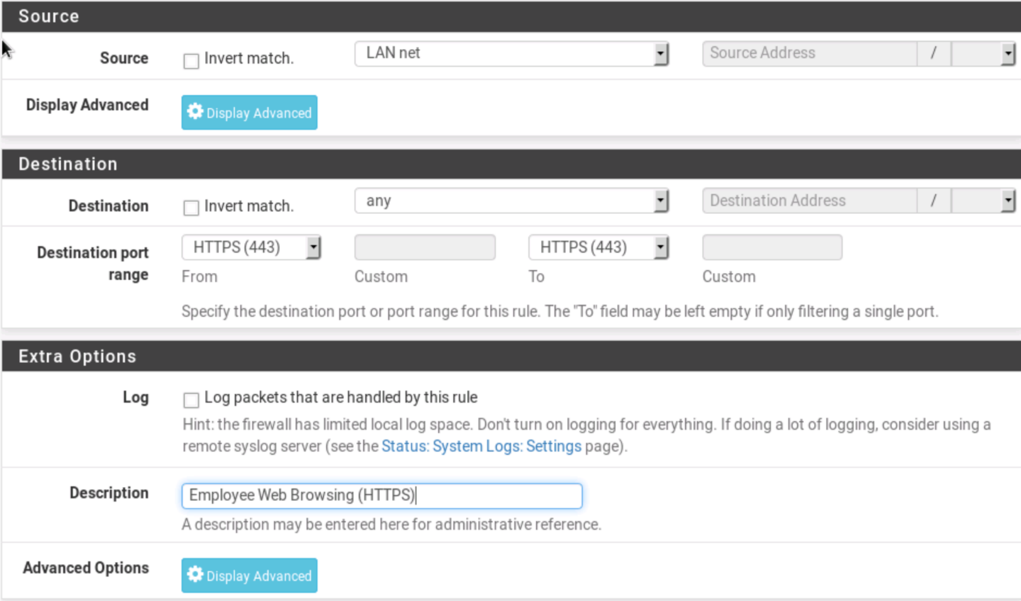

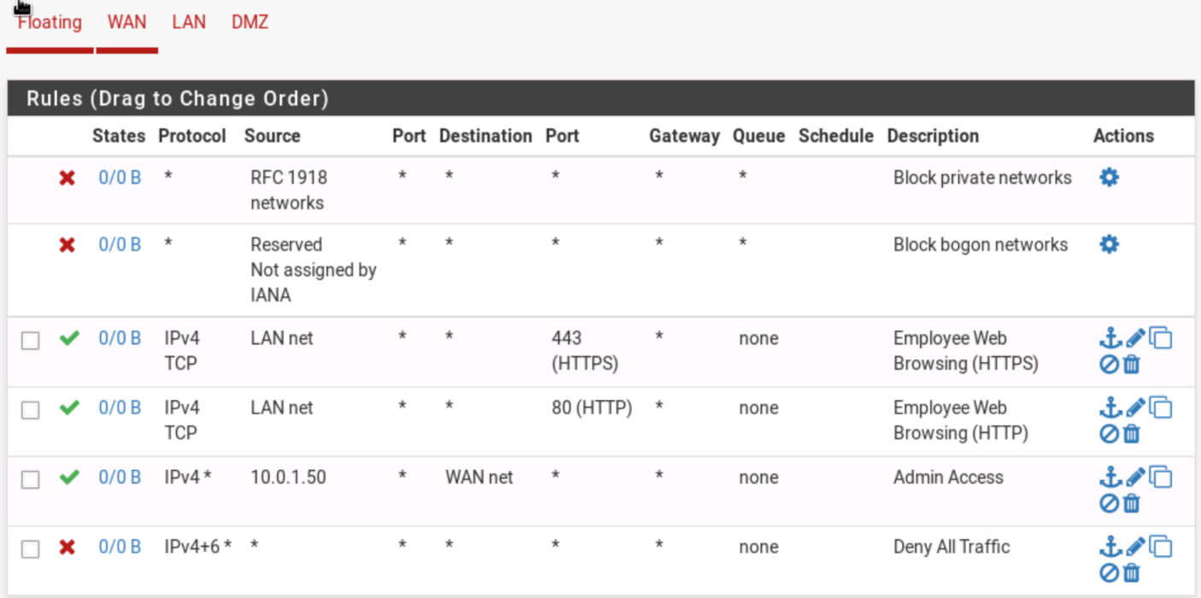

### 3.3.6 Mail Server WAN Rules

Select the same add button as before. Under destination, select **Single Host or Alias**, and enter the mail server IP of **10.0.1.2**. For the destination port, select **SMTP/S (465).** Enter "**SMTP/S to Mail Server**" in the Description. This rule will allow mail destined for our server through. Hit Save, then Apply Changes.

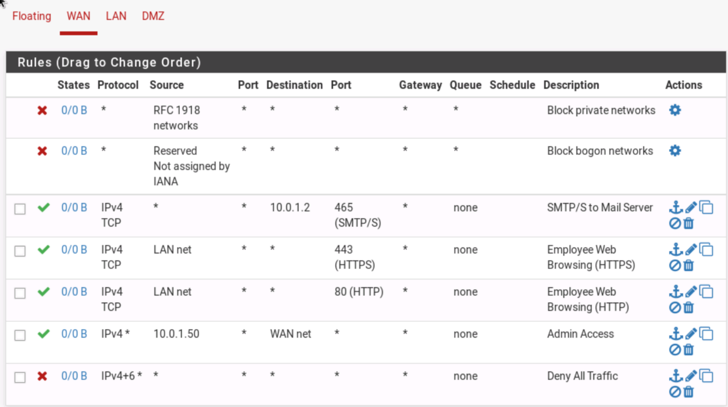

### 3.3.7 Web Server WAN Rules

Now we will create rules to allow web server traffic to reach the DMZ interface. Select the same **add** button as before. Select **TCP** for the protocol. Leave the source at any. For the Destination, select **Single Host or Alias**, then enter the Web Server IP address of **10.10.10.2**. Under destination port, select **HTTPS (443).** For the Description, enter "**External Web Server Access**". Hit Save, then Apply Changes.

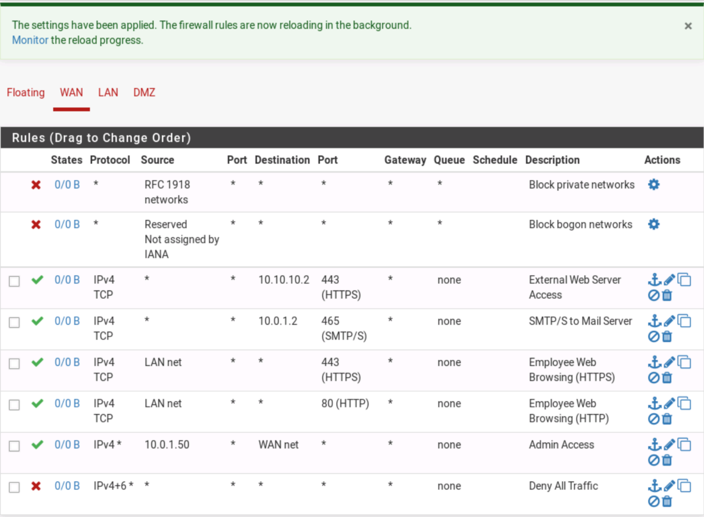

### 3.3.8 Testing MySQL

Next, we will create rules for our MySQL Database. The SQL server is in our DMZ, and is currently configured to only accept requests from the web server. Before we write them, let's try connecting to the database to ensure we don't have access to our current configuration. Open a terminal, and execute "**mysql -h 10.10.10.99 -u student -p**". When prompted for a password, enter **isaca**. Your CLI should be stuck after entering the password. Hit Ctrl+C to get back to the command prompt.

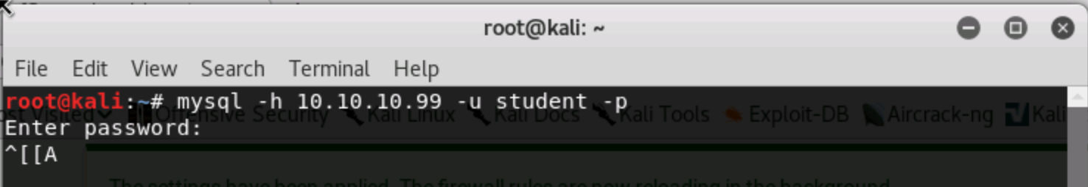

### 3.3.9 MySQL LAN Rules

Although we have rules allowing some traffic from the LAN to the DMZ, MySQL doesn't use HTTP so our requests were blocked. Back in the PfSense Web GUI, click **Firewall --> Rules --> LAN**. Select the green add button with an arrow pointing up.

### 3.3.10 MySQL LAN Rules II

Make sure TCP is the selected protocol. Select "**Single Host or Alias**" from the source options, and enter **10.0.1.50** for the source IP. Select "**Single Host or Alias**" from the destination options, and enter **10.10.10.99** for the destination IP. For Destination port range, enter a custom destination port of **3306**. This is the port our server is set to listen on. Enter "**Student MySQL Access**" in the Description. Hit Save, and Apply Changes.

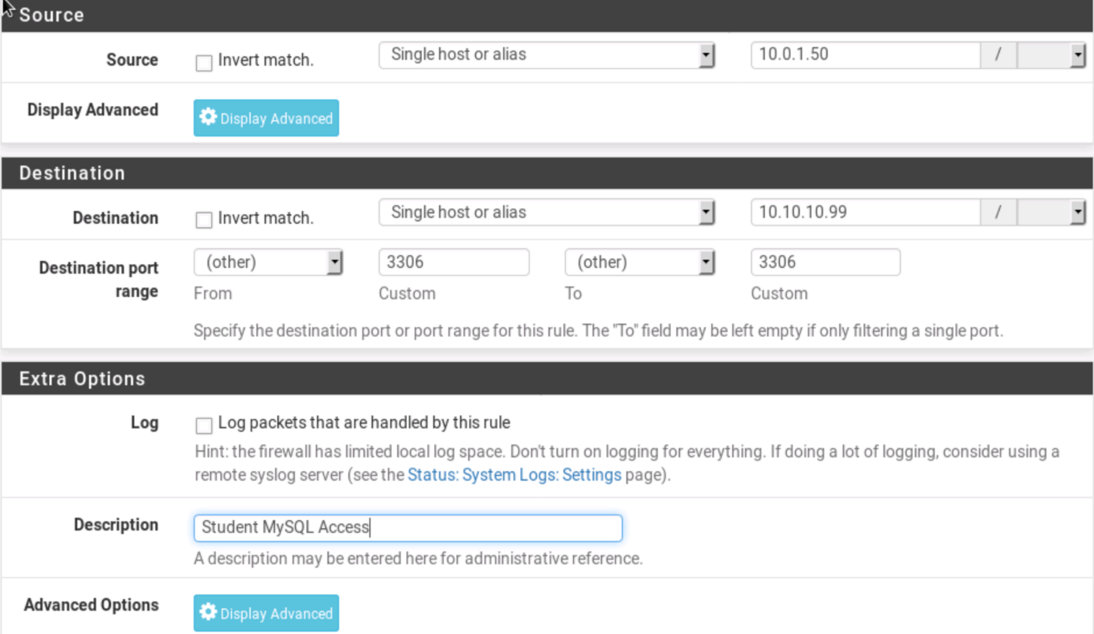

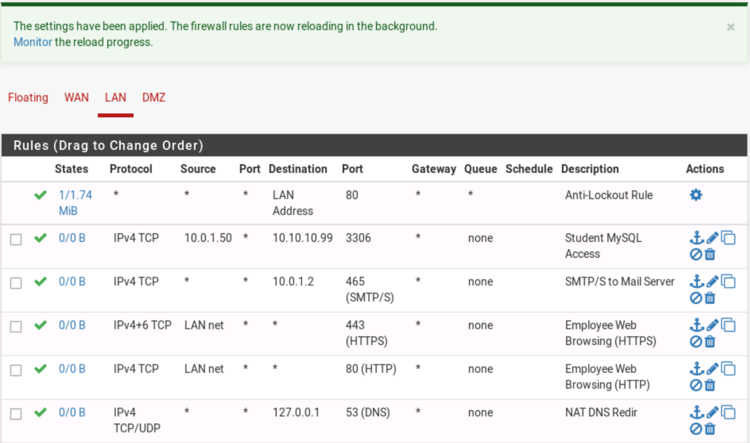

### 3.3.11 MySQL DMZ Rules

Under Firewall Rules, select the **DMZ** interface, then click the green add button with an arrow pointing up. Under protocol, select **TCP**. Under source, select **LAN Net**. Under destination, select "**Single Host or Alias**", and enter **10.10.10.99** for the destination address. Enter a custom destination port number of **3306**. Enter "**LAN MySQL Access**" for the description. Hit Save, then Apply Changes.

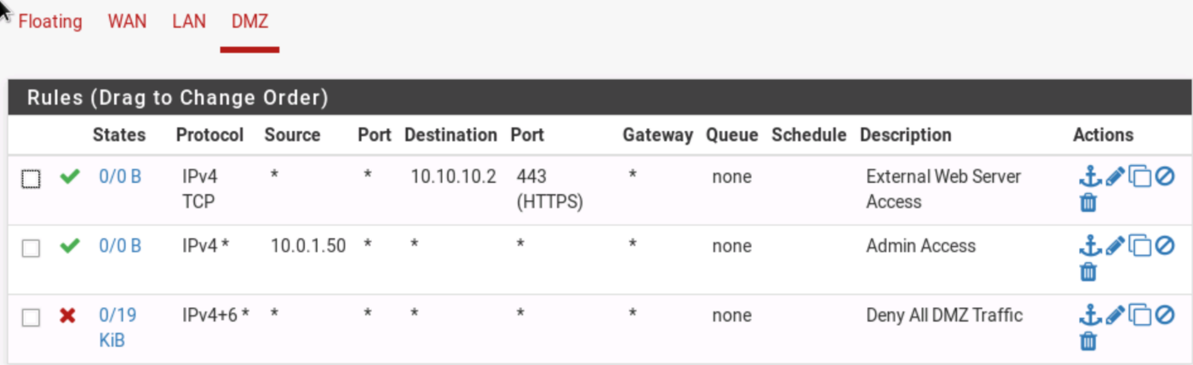

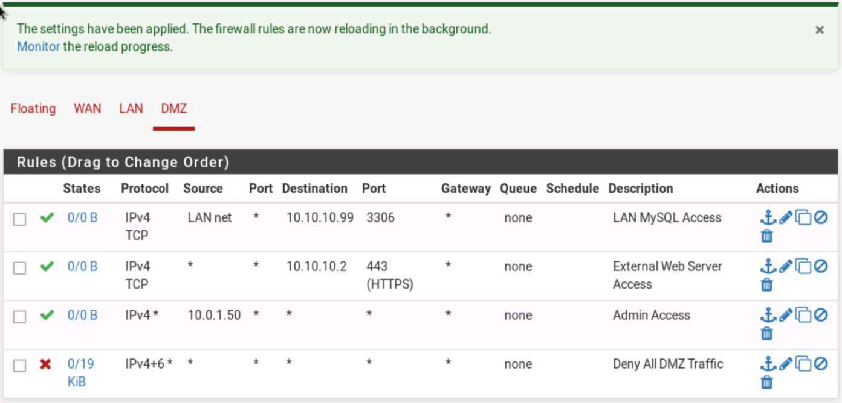

### 3.3.12 Testing MySQL

Let's test out the rules we just wrote. Open a terminal. Enter **'mysql -h 10.10.10.99 -u student -p'**. When prompted for a password, enter isaca.

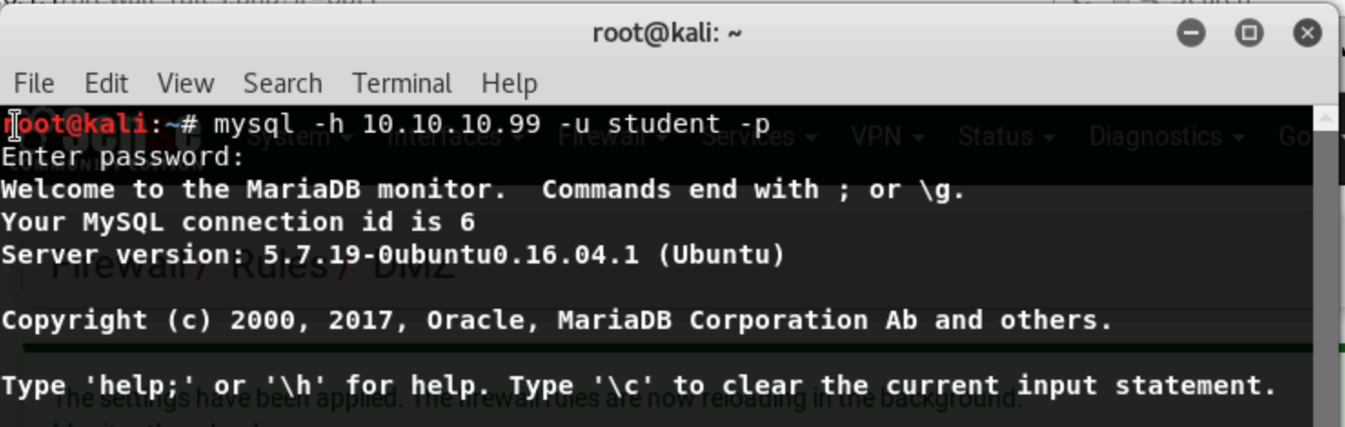

Congratulations! You should be connected to the MySQL db.

### 3.3.13 Successful Connection

Go back into PfSense and click Diagnostics --> Backup & Restore. Then download the Configuration as an XML, and save it to your Desktop as Firewall.xml

Unfortunately, your firewall rules are so strong Evalu8R can't get through! To give the grading system access to your machine, we need to create another firewall rule. In PfSense, click Firewall --> Rules --> LAN. Then create a rule with the following criteria:

Action: Pass

Address Family: IPv4

Protocol: Any

Source: Single Host or alias

Source Address: 10.0.1.50

Destination: Any

When you're done, hit Save then Apply Changes.

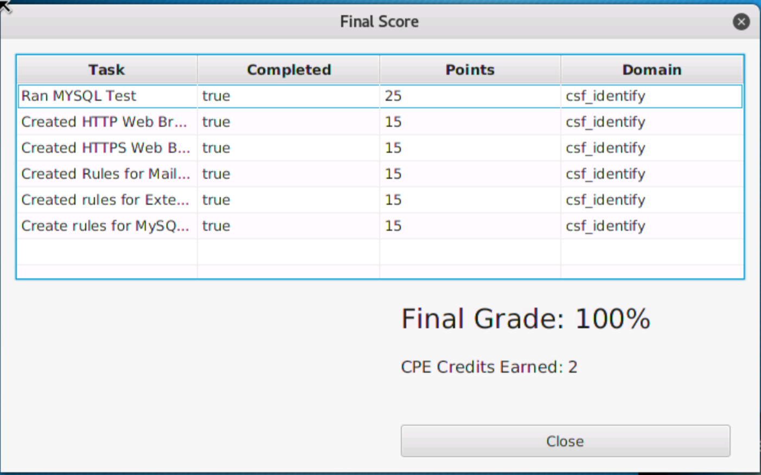

# Appendix Kali Tools

|  |  |
| --- | --- |
|  |  |
|  |  |

|  |  |
| --- | --- |
|  |  |
|  |  |

|  |  |
| --- | --- |
|  |  |
|  |  |

|  |  |
| --- | --- |
|  |  |

# Appendix IPv4 Subnet Calculator

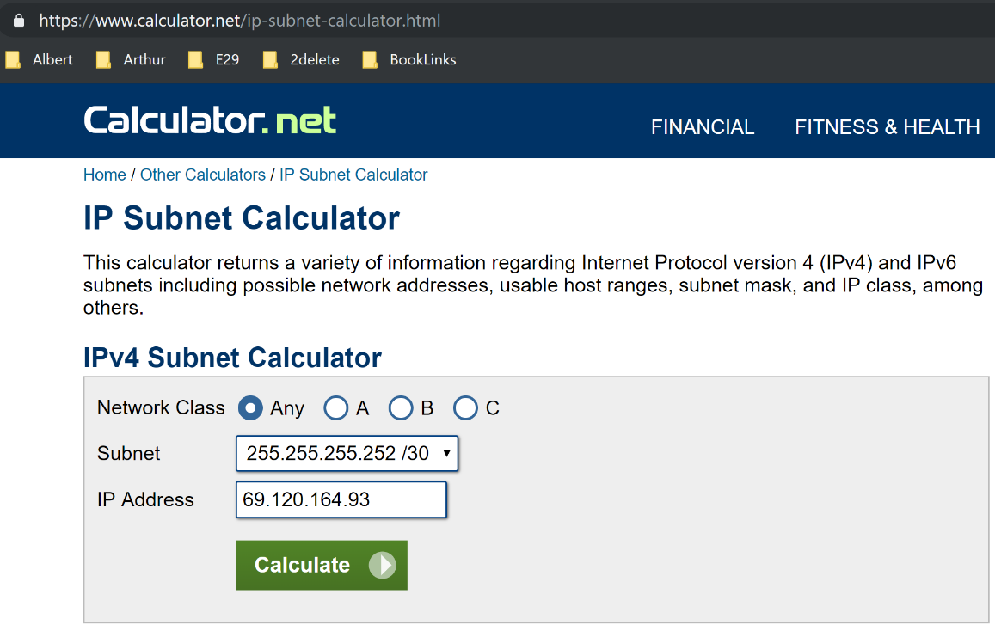

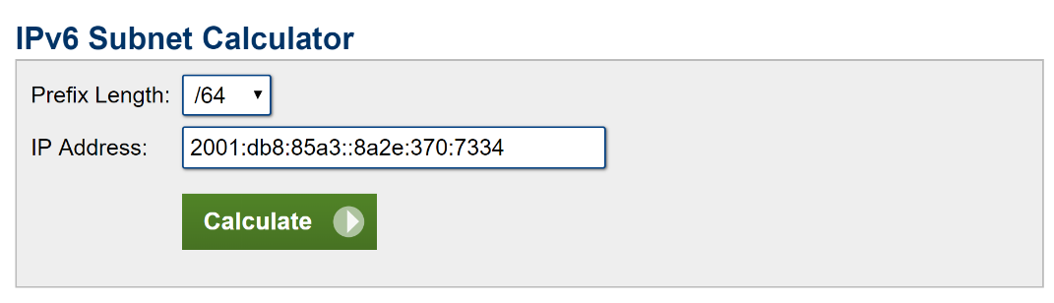

A subnet is division of an IP network (internet protocol suite), where an IP network is a set of communications protocols used on the Internet and other similar networks. It is commonly known as TCP/IP (Transmission Control Protocol/Internet Protocol). The act of dividing a network into at least two separate networks is called subnetting, and routers are devices that allow traffic exchange between subnetworks, serving as a physical boundary. IPv4 is the most common network addressing architecture used, though the use of IPv6 has been growing since 2006. An IP address is comprised of a network number (routing prefix) and a rest field (host identifier). A rest field is an identifier that is specific to a given host or network interface. A routing prefix is often expressed using Classless Inter-Domain Routing (CIDR) notation for both IPv4 and IPV6. CIDR is a method used to create unique identifiers for networks, as well as individual devices. For IPv4, networks can also be characterized using a subnet mask, which are sometimes expressed in dot-decimal notation, as shown in the "Subnet" field in the calculator. All hosts on a subnetwork have the same network prefix, unlike the host identifier which is a unique local identification. In IPv4, these subnet masks are used to differentiate the network number and host identifier. In IPv6, the network prefix performs a similar function as the subnet mask in IPv4, with the prefix length representing the number of bits in the address. Prior to the introduction of CIDR, IPv4 network prefixes could be directly obtained from the IP address based on the class (A, B, or C, which vary based on the range of IP addresses they include) of the address and the network mask. Since CIDRs introduction however, assigning an IP address to a network interface requires both an address and its network mask. Below is a table providing typical subnets for IPv4.

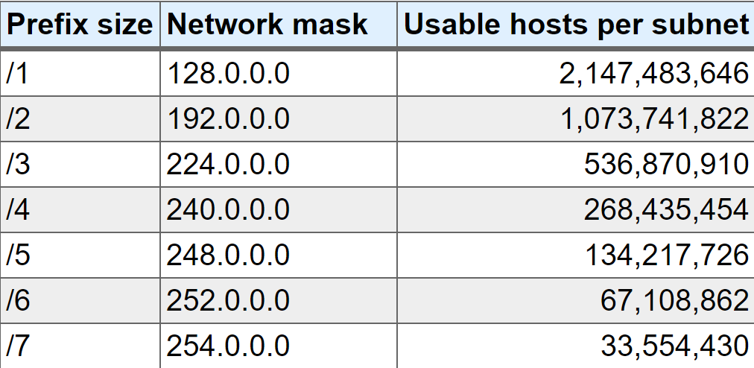

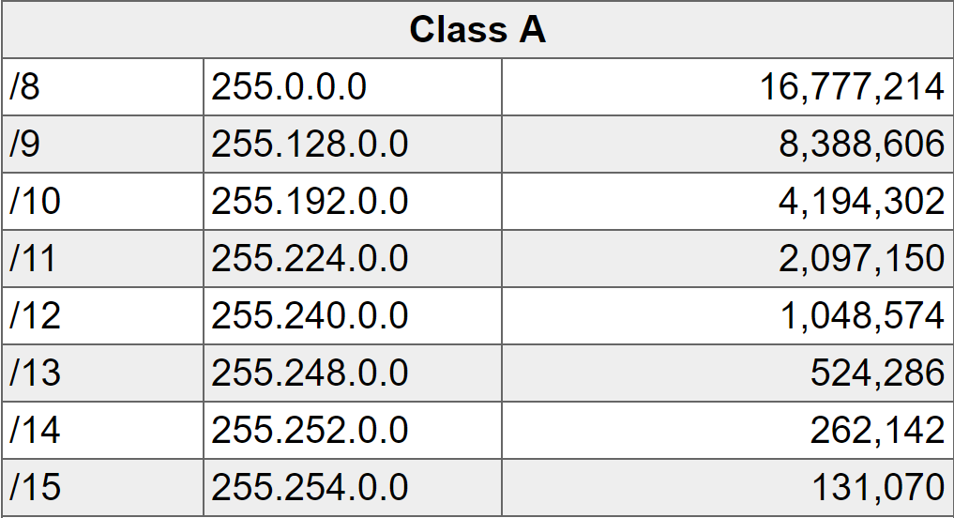

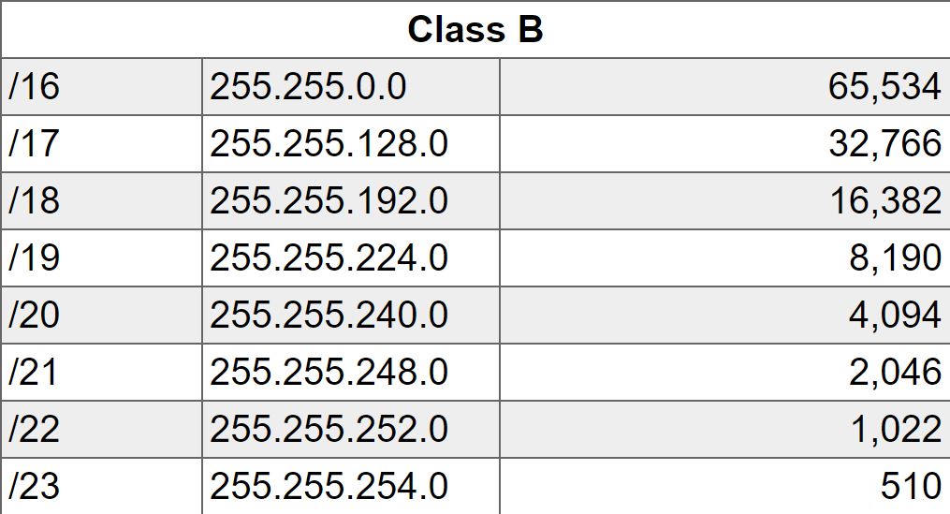

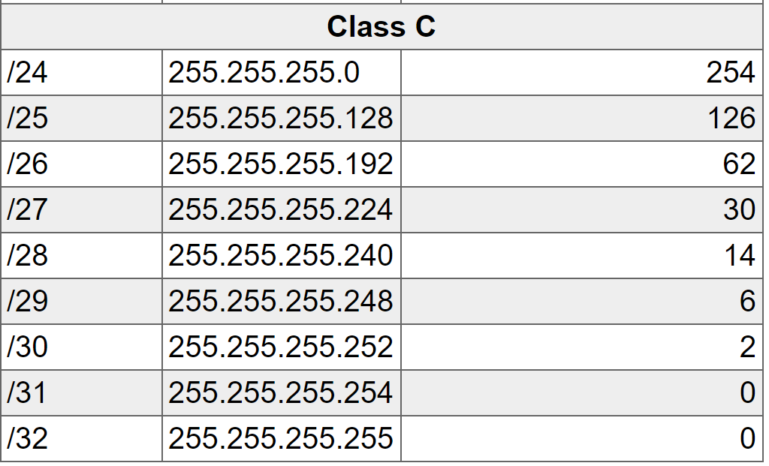

# Appendix Check Local & External IP address on Kali Linux

## Objective

The following article will illustrate some of the common ways on how to determine a local and public IP address on Kali Linux.

## External IP Address

### Using WEB Browser

Perhaps the simplest way on how to determine your Local and Public IP address is by using your web browser. Follow this link to [view your Local and Public IP address](https://linuxconfig.org/check-your-local-and-public-ip-address) instantly on your web browser. This page was specifically created for the purpose to promptly help our readers with this kind information.

### Using Command Line

wget and curl commands can be also used to discover your external IP address. Open up a terminal by right-clicking on your desktop and selecting the Open Terminal menu. Execute the following [linux command](https://linuxconfig.org/linux-commands)s to retrieve your external WAN IP address:

# echo $(wget -qO - https://api.ipify.org)

OR

# echo $(curl -s https://api.ipify.org)

## Internal IP Address

### Checking GUI Network Settings

The first method on how to find your local IP address on Kali Linux is by reviewing your network settings using a Graphical User Interface. The process on how you navigate to network settings is largely dependent on your desktop's GUI configuration. In case you are using a default Kali Linux desktop configuration, simply left-click on the top right network icon or power button. From there, click on tools button which will open up a settings window. On the All Settings window find and double click on the "network" icon. This will display your internal IP address allocated to your network card along side with DNS and gateway configuration.

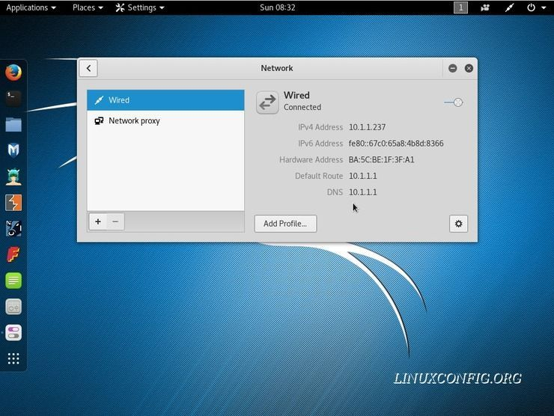

### Using ip or ifconfig commands

Probably to most common and perhaps even recommended way on how to list your internal IP address is by use of ip and ifconfig commands. Right-click on your desktop and select an "Open Terminal" menu to initiate a new terminal session. The following two commands will list all your internal IP addresses:

# ifconfig | grep -w inet | awk '{ print $2}'

OR

# ip a s | grep -w inet | awk '{ print $2}'

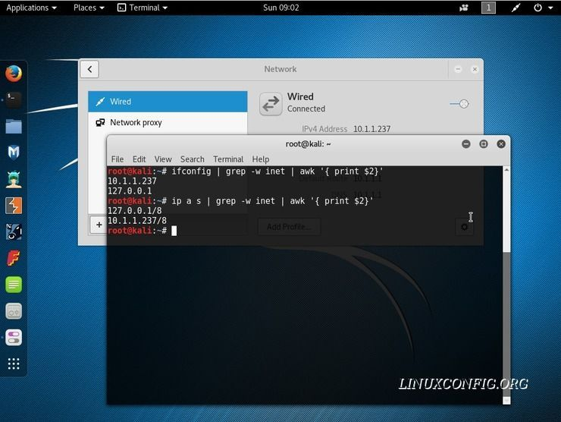

# Appendix Demystifying ifconfig and Network Interfaces in Linux

This post explains *ifconfig* output of common developer’s box, paying special attention to parameters poorly explained in official documentation. It also slightly touches Linux network interfaces.

## ifconfig

*ifconfig* is a command line tool for UNIX-like systems that allows for diagnosing and configuring network interfaces. At boot time, it sets up network interfaces such as Loopback and Ethernet. Most of the time, however, ifconfig is used for network diagnostics. Before diving into details of its output, let’s first make clear what is an interface.

## Network Interface

A *network interface* is a software interface to networking hardware. Linux kernel distinguishes between two types of network interfaces: *physical* and *virtual*. Physical network interface represents an actual network hardware device such as network interface controller (NIC). In practice, you’ll often find eth0 interface, which represents Ethernet network card.

Virtual network interface doesn’t represent any hardware device and is usually linked to one. There are different kinds of virtual interfaces: Loopback, bridges, VLANs, tunnel interfaces and so on. With proliferation of *software defined networks*, virtual interfaces become wildly used.

## Demystifying ifconfig output

Let’s have a look at ifconfig output for a developer’s box with installed Ubuntu and Docker.

$ ifconfig

docker0 Link encap:Ethernet HWaddr 02:42:2d:66:fc:f1

inet addr:172.17.0.1 Bcast:0.0.0.0 Mask:255.255.0.0

inet6 addr: fe80::42:2dff:fe66:fcf1/64 Scope:Link

UP BROADCAST MULTICAST MTU:1500 Metric:1

RX packets:2 errors:0 dropped:0 overruns:0 frame:0

TX packets:3 errors:0 dropped:0 overruns:0 carrier:0

collisions:0 txqueuelen:0

RX bytes:152 (152.0 B) TX bytes:258 (258.0 B)

eth0 Link encap:Ethernet HWaddr 08:00:27:31:65:b5

inet addr:10.0.2.15 Bcast:10.0.2.255 Mask:255.255.255.0

inet6 addr: fe80::3db9:eaaa:e0ae:6e09/64 Scope:Link

UP BROADCAST RUNNING MULTICAST MTU:1500 Metric:1

RX packets:1089467 errors:0 dropped:0 overruns:0 frame:0

TX packets:508121 errors:0 dropped:0 overruns:0 carrier:0

collisions:0 txqueuelen:1000

RX bytes:903808796 (903.8 MB) TX bytes:31099448 (31.0 MB)

lo Link encap:Local Loopback

inet addr:127.0.0.1 Mask:255.0.0.0

inet6 addr: ::1/128 Scope:Host

UP LOOPBACK RUNNING MTU:65536 Metric:1

RX packets:9643 errors:0 dropped:0 overruns:0 frame:0

TX packets:9643 errors:0 dropped:0 overruns:0 carrier:0

collisions:0 txqueuelen:1

RX bytes:719527 (719.5 KB) TX bytes:719527 (719.5 KB)

### Interfaces

There are 3 network interfaces on the box:

1. eth0 is a physical interface representing Ethernet network card. It’s used for communication with other computers on the network and on the Internet.
2. lo is a special virtual network interface called *loopback device*. Loopback is used mainly for diagnostics and troubleshooting, and to connect to services running on local host.
3. docker0 is a virtual bridge interface created by *Docker*. This bridge creates a separate network for docker containers and allows them to communicate with each other.

### Interface details

Let’s look closely at details of *ifconfig* output:

* Link encap shows how packets are encapsulated for transmission. Most interfaces wrap packets in *Ethernet* frames.
* HWaddr is hardware address of the ethernet interface (also known as MAC address).
* inet addr is IPv4 address assigned to the interface.
* Bcast is broadcast address for the interface.
* Mask is network mask for the interface.
* inet6 addr is IPv6 address assigned to the interface.
* Scope is scope of IPv6 address. It can be *link-local* or *global*. Link-local address is used in local area network and is not routable. Global address is routable.
* UP indicates that kernel modules related to the interface have been loaded and interface is activated.
* BROADCAST indicates that interface is configured to handle broadcast packets, which is required for obtaining IP address via DHCP.
* RUNNING indicates that interface is ready to accept data.
* MULTICAST indicates that interface supports multicasting.
* MTU is maximum transmission unit. IP datagrams larger than MTU bytes will be fragmented into multiple Ethernet frames.
* Metric determines the cost of using the interface. Interfaces with lower cost have higher priority.

### Interface stats

* RX packets is a total number of packets received.
* RX errors shows a total number of packets received with error. This includes too-long-frames errors, ring-buffer overflow errors, CRC errors, frame alignment errors, fifo overruns, and missed packets.
* RX dropped is a number of dropped packets due to unintended VLAN tags or receiving IPv6 frames when interface is not configured for IPv6.
* RX overruns is a number of received packets that experienced fifo overruns, caused by rate at which a buffer gets full and kernel isn’t able to empty it.
* RX frame is a number of misaligned frames, i.e. frames with length not divisible by 8.
* TX packets is total number of packets transmitted.
* TX errors, TX dropped and TX overruns are similar to RX equivalents.
* TX carriers is a number of packets that experienced loss of carriers. This usually happens when link is flapping.
* TX collisions is a number of transmitted packets that experienced Ethernet collisions.
* TX txqueuelen is length of transmission queue.
* RX bytes is a total number of bytes received over interface.
* TX bytes is a total number of bytes transmitted over interface.

## Summary

Despite being superseded by *ip* command, *ifconfig* is still commonly used and provides lots of useful details about network interfaces, both physical and virtual.

# Appendix The "arp" Command

arp displays and modifies entries in the Address Resolution Protocol (ARP) cache, which contains one or more tables that are used to store IP addresses and their resolved Ethernet or Token Ring physical addresses. There is a separate table for each Ethernet or Token Ring network adapter installed on your computer. Used without parameters, arp displays help. You can use the arp command to view and modify the ARP table entries on the local computer. This may display all the known connections on your local aream network segment (if they have been active and in the cache). The arp command is useful for viewing the ARP cache and resolving address resolution problems.

**Syntax (Inet means Internet address)**

arp [-a [InetAddr] [-N IfaceAddr]] [-g [InetAddr] [-N IfaceAddr]] [-d InetAddr [IfaceAddr]] [-s InetAddr EtherAddr [IfaceAddr]]

Here are the switch definitions:

-a [InetAddr] [-NIfaceAddr] : Displays current ARP cache tables for all interfaces. To display the ARP cache entry for a specific IP address, use arp -a with the InetAddr parameter, where InetAddr is an IP address. To display the ARP cache table for a specific interface, use the -N IfaceAddr parameter where IfaceAddr is the IP address assigned to the interface. The -N parameter is case-sensitive.

-g [InetAddr] [-NIfaceAddr] : Identical to -a.

-dInetAddr [IfaceAddr] : Deletes an entry with a specific IP address, where InetAddr is the IP address. To delete an entry in a table for a specific interface, use the IfaceAddr parameter where IfaceAddr is the IP address assigned to the interface. To delete all entries, use the asterisk (*) wildcard character in place of InetAddr. So "arp -d *" will flush your ARP cache.

-sInetAddr EtherAddr [IfaceAddr] : Adds a static entry to the ARP cache that resolves the IP address InetAddr to the physical address EtherAddr. To add a static ARP cache entry to the table for a specific interface, use the IfaceAddr parameter where IfaceAddr is an IP address assigned to the interface.

/?: Displays help at the command prompt.